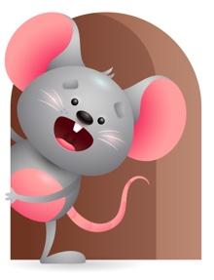
Peek at Our Week

Standard Focus | Activity | Home Extension Activity
Physical Development-Younger-Demonstrates use of large muscles to move in the environment. Older- Demonstrates increasing interest in eating habits and making food choices. | Younger- Practice using large muscles to sit without help and reaching for toys. Older- Practice picking up a variety of finger foods and holding cup to drink. | Younger- While on the floor let them practice rolling from tummy to back and raising their head. Older- Give them different foods to eat so they can see what they like. Practice with a spoon.
Social and Emotional-Younger- Building and maintaining relationships with adults and peers. Older- Develops sense of identity and belonging through play. | Younger- While playing on the floor with them, singing, talking, cuddling, and rocking they start to build a relationship with you. Older- During play they develop a sense of who they are-where they are and looks for adult for attention. | Younger- Spend some one on one time with them just sing, laugh, play, rock, or just talk a while and let them build on their relationship with you. Older- Play a game through the day just go through the house and tell them look this is your bed, toys, clothes.
,Mathematical Thinking-Younger- Explores objects in hands. Older- Explores objects with different characteristics. | Younger- Give them some blocks to explore and then stack them as you count 1-3. Older- Explore different things that are soft and hard- blankets, balls, blocks. | Younger- Give them things that they can explore with their hands-( balls, books, blocks). Older- Show them different things that are round, hard, soft, square(balls, blocks, blankets).

Parent Resources

Other News- We will continue to do the traditional daily and table prayers including the sign of the cross – and now we will add listens to bible stories. We will read the Christmas story, The Story of Baby Jesus, Stable in Bethlehem, and When Jesus was a little Boy.

