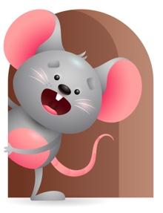
Peek at Our Week

Standard Focus | Activity | Home Extension Activity
Social Emotional-Younger- Experiences and develops secure relationship with a primary caregiver. Older- Shows interest and inclination to explore without adult direction. | Younger- we will rock them to sleep and sing to them, talk when we change their diapers, and sit on the floor and interact in play. Older- Set up play time and then sit back and watch them play without direction. | Younger- Take time to let them have a secure relationship with you(cuddle them, eat with them, tell them a bedtime story and rock them to sleep, sing or hum a song and make them feel relaxed. Older- Continue to let them play without direction-put some of their toys out and sit and watch what they do.
Mathematical Thinking-Younger- Explores objects and watches how they move. Older- Patterns- explore different shapes. | Younger- They will watch objects as they move to see how they work-Ask them can you shake it? Roll it? ( show them how to do it) then ask do you hear any sounds (put it up to their ear). Older- Play with shape sorter and explore all the shapes, as they put them in the bucket you can count them as they drop them in. | Younger- show them how some of their toys move and work. Do they have lights? Make sounds? Roll? Sit and show them how it works. Older- give them different shapes to play with (Ball for round, blocks for square).
Language and Literacy-Younger-Reacts to environmental sounds and verbal communication. Older- Shows enjoyment of sounds and rhythms of language. | Younger- While playing on the floor carry on a conversation with them-just talk to them. What are you playing with ?Do you like the sound you hear? Older-Name all the animals you can and make their sound. Sing some Nursery Rhymes- Hey diddle diddle, Baa Baa Black sheep. | Younger- Let them hear different sounds around your house ( Daddy mowing the grass, doorbell or telephone ringing, music playing. Tell them what the sounds are. Older- Let them hear sounds from your house too and tell them what it is.

Parent Resources

Other News-Dec.22@3pm-Christmas Program

