Peek at Our Week
Standard Focus | Activity | Home Extension Activity
- Begins to explore a greater variety of motions with objects (e.g., rotate, spin, twist) | String Bells on Pipe Cleaner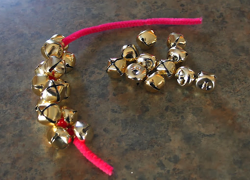 | Christmas time is a great time to string items. String beads or bells for your tree or as a garland.
- Demonstrates use of large muscles for movement, position, strength and coordination | Play “Packing and Pushing/Pulling Santa’s Sled”  Fill Santa’s sled with presents and push it around the playground. (blue wagon with blocks) | Heavy work is important for the development of your child’s large muscles. I have printed a list of “heavy work” activities for your child to do at home.
- Increases knowledge through listening  - Responds to an adult’s simple questions about what is being learned  - Asks questions, and responds to adults and peers in a variety of settings  - Asks and responds to simple questions (e.g., “Who?” “What?” “Where?” “Why?”) using gestures and two- or three-word phrases in back-and-forth exchanges | 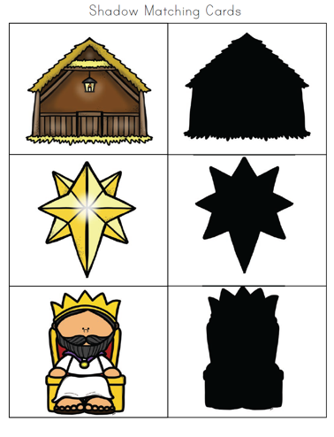 | Using a flashlight make shadows of object you have around the house. Have your child guess what object is making the shadow.
Parent Resources: Heavy work handout attached.

