Standard | Activity | Home Extension
Faith Formation Standard: "L-LR Liturgical Resources: Liturgical Calendar [1163-1173]"  PK.L.LR.1 Identify the special seasons in the Liturgical Calendar: Advent, Christmas, Epiphany, Lent and Easter and special feasts of Mary and the saints. | What is Advent?  Advent is a time of waiting and preparation of the birth of Jesus.  Paint Purple Advent candle for classroom 2nd Week 3 of Advent- 2 Purple candles, 1 Pink candle and Last Purple Candle (Hope) (Love) (Joy) Peace  ( See back for prayer) | 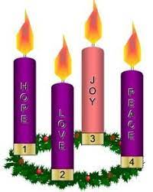  Set up an Advent wreath in your home and light the candles each week as we prepare for the birth of Jesus.
Standard: D. Geometry: 8-18 months 1. Notices shapes in the environment 18-24 months 1. Begins to match basic shapes 2. Begins to sort familiar objects into two groups based on size. | Provide opportunities for children to explore and manipulate objects with varying characteristics (e.g., color, size, shape, texture). Add various items of size shape color. | Add basic geometric shapes in different size and colors to your Christmas tree for children to search for and name.
Standard: A. Sensory Art Experience. 1. Combines a variety of open-ended, process-oriented and diverse art materials to explore technique with intention. | Taste and decorate Gingerbread cookies. Provide colored icing for the children to fingerpaint their personal gingerbread cookie. | Decorate cookies with your children and create a new tradition.

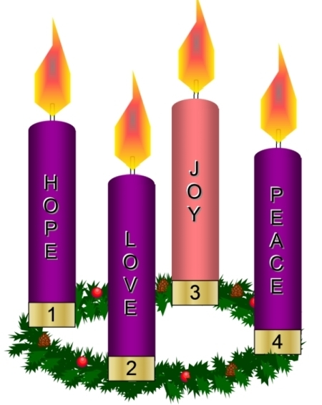
This week we focus our hearts on the “Lord of peace” who came down from heaven in the form of a baby. God knows that we are in a constant battle against fear! Fear wants to cripple us, to push us to react rather than carefully respond, and fear steals our joy. God has given us the gift of peace so we can live joy-filled lives!

Have a very Merry Christmas!!

