Standard | Activity | Home Extension
Faith Formation Standard: "L-LR Liturgical Resources: Liturgical Calendar [1163-1173]"  PK.L.LR.1 Identify the special seasons in the Liturgical Calendar: Advent, Christmas, Epiphany, Lent and Easter and special feasts of Mary and the saints. | What is Advent?  Advent is a time of waiting and preparation of the birth of Jesus.  Paint Purple Advent candle for classroom 2nd Week 2 of Advent- 2 Purple candles.  (Hope) Love ( See back for prayer) | 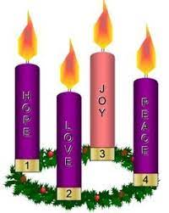  Set up an Advent wreath in your home and light the candles each week as we prepare for the birth of Jesus.
Standard: Vocabulary: 2. Uses increased vocabulary to describe objects, actions and events (expressive) 8-18 month Benchmark a.Builds and uses vocabulary through repeated exposure with language, pictures and books (may have a speaking vocabulary of between 10-50 words) 18-24 month Benchmark a.Uses a number of different words and begins using two or more words together | Repeat words from The Nativity story or finger-play. Provide opportunities each day for finger-plays, songs and stories. | Read books to children and ask them questions about the pictures.  Sing songs with children and have the children repeat words from the songs.
Standard : A. Sensory Art Experience 1. Combines a variety of open-ended, process-oriented and diverse art materials to explore technique with intention. | Christmas Scented oatmeal and cheerio sand Use Christmas Cookie cutters to paint with scented paints. Add pieces of different colors of garland to the sensory bin. | Crush Cheerios to create “sand” children can manipulate the sand and it is safe if they eat it. Add different Christmas scents to the sand for variety.
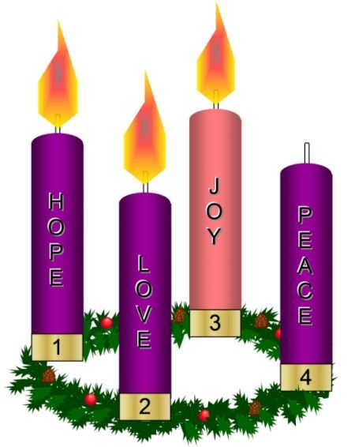

Heavenly Father, this third week of Advent, let us remember that the good news of Jesus’ birth has the power to bring us great joy this Christmas season. Our joy is not dependent on what is going on in our life, in our world, or the people that we are with. It doesn’t depend on the gifts we give or the gifts we find under the tree. No earthly thing can ever give us complete joy. Our joy comes from you. That joy that flooded the hearts of the shepherds, the angels, the wise men, the hosts of heaven, and Mary and Joseph is the joy that still has the power to overwhelm our hearts with rejoicing.

