Standard | Activity | Home Extension
Faith Formation Standard: "L-LR Liturgical Resources: Liturgical Calendar [1163-1173]"  PK.L.LR.1 Identify the special seasons in the Liturgical Calendar: Advent, Christmas, Epiphany, Lent and Easter and special feasts of Mary and the saints. | What is Advent?  Advent is a time of waiting and preparation of the birth of Jesus.  Paint Purple Advent candle for classroom Week 1 of Advent- 1 Purple candles.  (Hope) ( See back for prayer) | 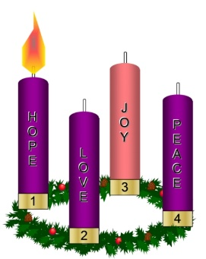  Set up an Advent wreath in your home and light the candles each week as we prepare for the birth of Jesus.
Standard: Vocabulary: 2. Uses increased vocabulary to describe objects, actions and events (expressive) 8-18 month Benchmark a.Builds and uses vocabulary through repeated exposure with language, pictures and books (may have a speaking vocabulary of between 10-50 words) 18-24 month Benchmark a.Uses a number of different words and begins using two or more words together | Repeat words from The Nativity story or finger-play. Provide opportunities each day for finger-plays, songs and stories. | Read books to children and ask them questions about the pictures.  Sing songs with children and have the children repeat words from the songs.
Standard : A. Sensory Art Experience 1. Combines a variety of open-ended, process-oriented and diverse art materials to explore technique with intention. | Christmas Scented oatmeal and cheerio sand Use Christmas Cookie cutters to paint with scented paints. Add pieces of different colors of garland to the sensory bin. | Crush Cheerios to create “sand” children can manipulate the sand and it is safe if they eat it. Add different Christmas scents to the sand for variety.

The first week of Advent we remember the gift of hope we have in Christ. The
prophets of Israel all spoke of the coming of Christ, of how a savior would be born, a king in
the line of David. They spoke of how he would rule the world wisely and bless all nations.
As followers of Christ, we wait with hope for his return. As we light this candle, we remember
that it was from the manger at Bethlehem that he came and gave light to the world. As we light this candle,
we are reminded to be alert and to watch for the light of Christ even in the most unlikely places and people.

