Weekly Peaks
Activity | Standards | Home Extensions
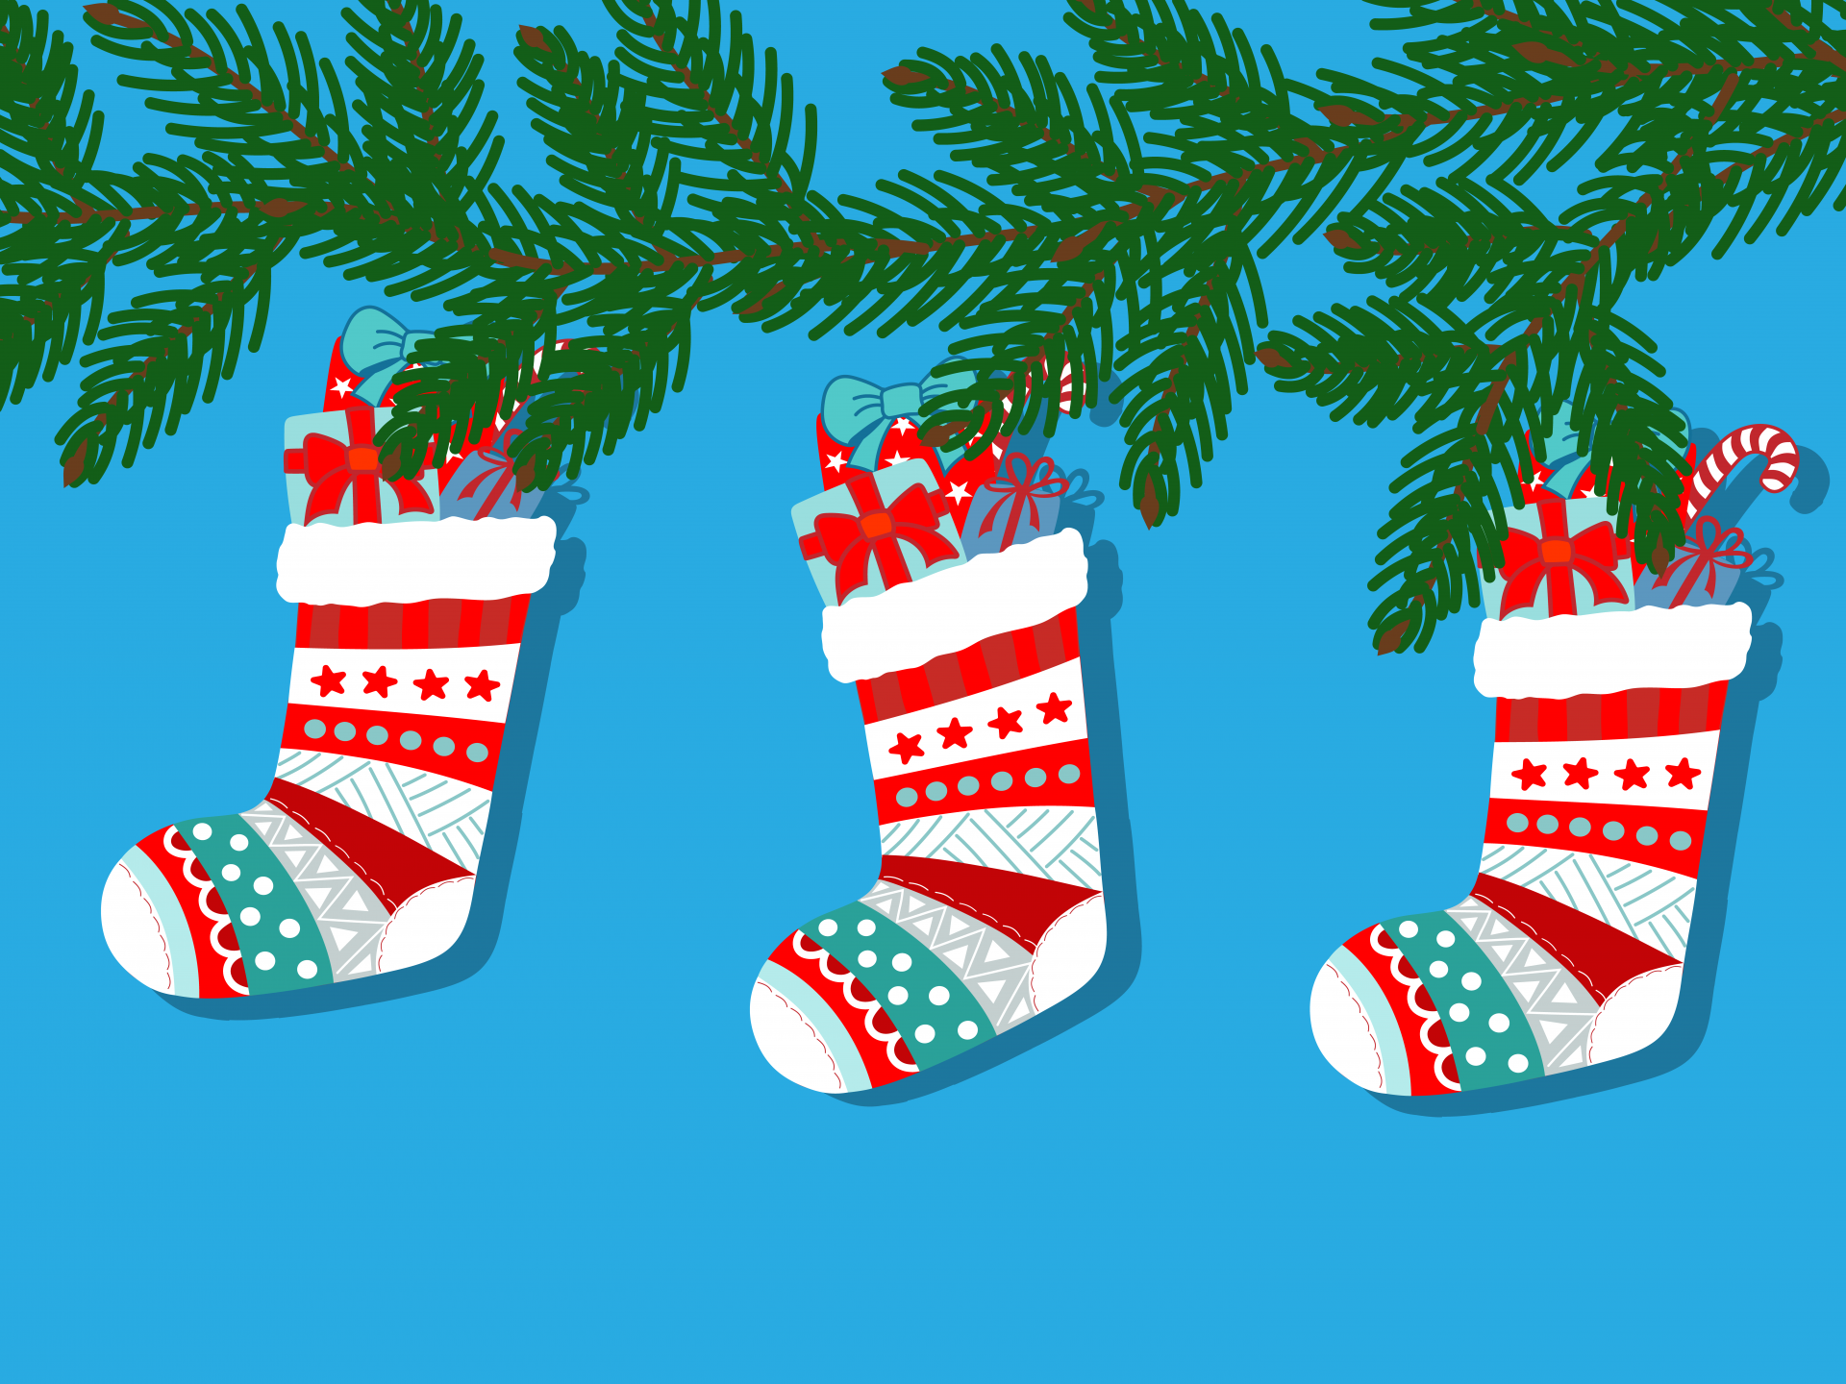  Social Studies  The children will learn about St. Lucia and make hot crossed buns as well as have hot chocolate for snack time. | A. CULTURE  2. Identifies the ways self is similar to and different from peers and others. | Do a family tradition or make a new family tradition with the child (bake cookies, Make reindeer food, pictures with Santa, church, etc.)
Creative Expression  The children will act out what Shepherds are and create different animals that they herd (sheep, reindeer, etc.) | D. IMAGINATIVE AND CREATIVE PLAY  1. Expresses and represents thoughts, observations, imagination, feelings, experiences, and knowledge, verbally or non-verbally, with others using a variety of objects in own environment. | Ask children what their favorite story is. Have them reenact or retell it to you.
Physical Development  The children will use marshmallow fluff, sun butter, graham crackers, and gingerbread to make a stable / house. Children may decorate their gingerbread houses with frosting, sprinkles, marshmallows, gumballs, and hard candies. | Fine Motor: Standards:  Benchmark a.  Easily coordinates hand and eye movements to carry out tasks (e.g., working on puzzles or stringing beads together). | Have children string popcorn onto thread with some guidance.

