Weekly Peak
Brandy Layton – twos Senses Unit Oct 16th -20th 2023
Standards | Activates | Home Extension
Scientific Inquiry  A. SCIENTIFIC INQUIRY THROUGH EXPLORATION AND DISCOVERY  2-3 years (24-36 months)  1. Uses senses to explore and understand their social and physical environment  Benchmark a.  Identifies sense organs (e.g., nose, mouth, eyes, ears and hands)  Benchmark b.  Begins to use senses to observe and experience the environment.  Physical development  Health and Wellbeing  b. Safety  2-3 years (24-36 months)  1. Shows awareness of safety and increasingly demonstrates knowledge of safe choices and risk assessment when participating in daily activities  Benchmark a.  Demonstrates difference between safe and unsafe play behaviors (e.g., chairs are for sitting, keeps inappropriate items out of nose/mouth  Mathematical Thinking  D. GEOMETRY  2-3 years (24-36 months)  1. Matches basic shapes (circle, square) nonverbally | Carve a Pumpkin. Have children describe the texture of the whole pumpkin  Discuss Adam and Eves sin. And how they use could’ve used their brave talk.  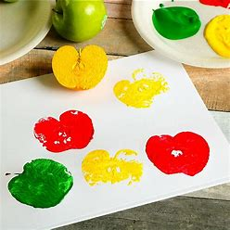  Apple stamping | Encourage and expose child to an increasing variety of sensory experiences.  Allow child to participate in safety and self-care activities, allowing independence but remaining nearby to offer assistance if needed.  Have a “shape hunt.” Give children a shape to look for and see how many they can find.

