Weekly Peak
Brandy Layton – twos Senses Unit Oct 30th – Nov 3rd 2023
Standards | Activities | Home Extension
Scientific Inquiry  A. SCIENTIFIC INQUIRY THROUGH EXPLORATION AND DISCOVERY  2-3 years (24-36 months)  1. Uses senses to explore and understand their social and physical environment  Benchmark a.  Identifies sense organs (e.g., nose, mouth, eyes, ears and hands)  Benchmark b.  Begins to use senses to observe and experience the environment.  Language and Literacy  A. LISTENING AND UNDERSTANDING  2-3 years (24-36 months)  3. Follows directions  Benchmark a.  Follows multi-step directions with reminders.  Scientific Inquiry  A. SCIENTIFIC INQUIRY THROUGH EXPLORATION AND DISCOVERY  2-3 years (24-36 months)  1. Uses senses to explore and understand their social and physical environment  Benchmark a.  Identifies sense organs (e.g., nose, mouth, eyes, ears and hands)  Benchmark b.  Begins to use senses to observe and experience the environment. | Talk about taste what body part do we use to taste things with. What things can we taste? (different food). Class will be making apple Sauce.  Halloween parade @9:30  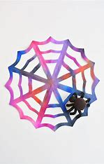  Make little spider webs.  Halloween party 3:30 Parents welcome  Make Orange juice with the children have them try it after. What does it taste like? | Make some bread let child need the dough.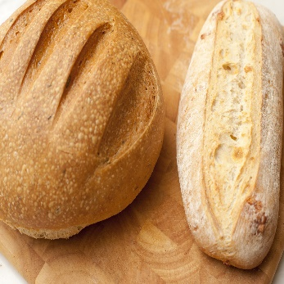  Practice proper Hand washing at home go step by step. Sing “Happy Birthday to you” x2  Make some Orange juice to have with your breakfast have children squeeze the juicer

