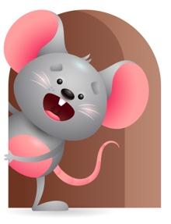
Standard Focus | Activity | Home Extension Activity
Approaches to Learning-Younger- Shows awareness of and interest in the environment. Older-Notices and shows interest in familiar objects, people, and events. | Younger- Explore the environment and see what your senses can do. Touch and feel objects by mouthing, shaking, banging and seeing what they do. Older- Read My Favorite Pets- A touch and feel book- Make the animal sounds. Go outside and let them smell different objects. | Younger- Show them how things work. Push a car-Shake a rattle- Play with a pop-up toy- roll balls. Older- Read books that have familiar objects in them- cars-balls-blocks-people-animals. Tell what each one does and make sounds for the animals.
Social Studies-Younger- Time, Continuity and Change. Older- Begins to explore characteristics of self-eyes, nose, hair. | Younger- Practice doing things at the same time every day. Lunch, diapers, play time and nap- they will begin to respond to time and schedules. Older- We will move around and see what we can do with our bodies. Clap your hands, touch your ears, close your eyes. | Younger- Continue to stay on a schedule so they will become aware of what time it is. Older- Play a game and ask them to touch their nose, ears, legs (and so on).Let them smell different things in your house.
Physical Development-Younger- Beginning signs of strength, control, and eye-hand coordination. Older- Responds to feeding self and making food choices. | Younger- We will practice shaking rattles, playing with pop-up toy, reaching, and holding on to object. Older-We will practice picking up finger foods and eating them. Let them smell their food. | Younger- Give them objects they must hold and squeeze or shake. Older- Let them practice holding cups, bottles, and spoons to feed themselves. Let them smell the foods you give them.

Parent Resources

Other News-

