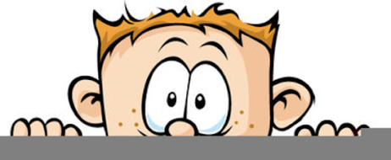

Peek at Our Week
Standard Focus | Activity | Home Extension Activity
- Explores own environment  - Shows increased eagerness and curiosity as a learner | 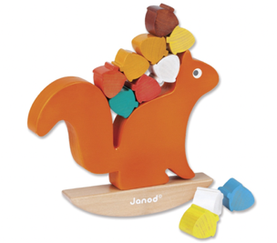  Squirrel Balancing Puzzle | Balancing objects exercises your child’s gross and fine motor skills, requires planning, persistence, and self-control. Look around your house and see what items you can stack and balance. Be creative! Simple wooden balancing puzzles are available on Amazon.
- Recognizes a simple AB pattern (e.g., clap/snap, clap/snap, clap/snap) | Use green pipe cleaner and large and small orange buttons to make pumpkins on a vine. | Buttons are a great item to use for stringing and pattern making. Large bags of assorted color and size buttons are available to Walmart and on Amazon. You string onto pipe cleaners, yarn or thin shoes laces.
- Communicates to adults when hungry, thirsty or has had enough to eat | The children will be encouraged to communicate verbally to adults when they need to use the potty, are hungry, thirsty or has had enough to eat. They will also be directed to listen to their bodies to determine these needs. | When your child asks for a drink, ask them if, they are thirsty. Then ask, how do they know that they are thirsty. Point out to them that maybe their mouth is dry, or they are hot and sweaty. Use the same method for hungry, tired, or need to use the potty. Understanding the signals that our body’s send us is an important skill to learn.

