Peek at Our Week
Standard Focus | Activity | Home Extension Activity
- Begins to use senses to observe and experience the environment | The children will use a mortar and pestle to crush herbs and spices and then mix them into their playdough. | See the back of this paper for a playdough recipe you can make at home.
- Begins to use senses to observe and experience the environment | Identify Smells:  Fill small containers with cotton balls with different essential oils. Have the children try to guess the scents. Graph the children’s responses and hang in the classroom. | Put a blindfold on your child and have them try to identify different smells from your kitchen such as lemon, pickle, coffee, vanilla or mustard.
- Attends to sights, sounds, objects, people and activities  - Develops sense of identity and belonging through play  - Continues to engage in parallel play but also begins to play with other preferred playmates | Making Felt Apple Pies  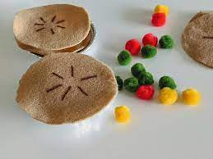 | Felt and colored pompoms can be used to make many pretend food items for your child. Circle of brown felt can be cookies, pie crust, pizza crust or pancakes. Small red circles can be peperoni. Small yellow squares can be butter, cheese or crackers. Small red pompoms can be apples for apple pie.
Parent Resources: This week’s focus is smell.

