Peek at Our Week
Standard Focus | Activity | Home Extension Activity
- Recognizes a simple AB pattern | Make patterns with fruit counters. 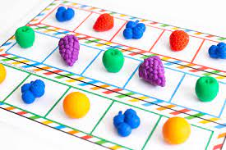 | Lots of different items you have at home can be used to make patterns such as fork, spoon, fork, spoon or shoe, sock, shoe, sock. Look around the house and get creative!
- Uses senses to explore and understand their social and physical environment  - Identifies sense organs (e.g., nose, mouth, eyes, ears and hands)  - Begins to use senses to observe and experience the environment | 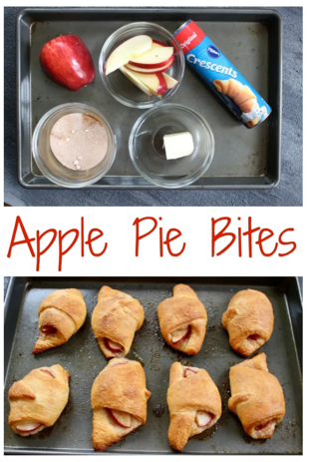 | Fine motor skills, math concepts, and following directions are just a few areas that cooking with your kids helps to develop. There are toddler-safe knives available on Amazon. Let your child stir, measure, and pour ingredients. Use this time to build their vocabulary by using cooking terms such as: bake, broil, sauté, chop, slice, and fry. Studies have also shown that children are more likely to eat something new if they helped cook it.
- Continues to engage in parallel play but also begins to play with other preferred playmates | A sensory bin will be filled with apple pie scented oatmeal and another will be filled with split peas and garbanzo beans died to look like pumpkins. | Sensory bins are easy to make and provide great experience for your child. Use any shallow container, a box, plastic bin, or metal baking pan. Fill it about halfway with oatmeal. Add a small amount of any other small objects to the bin such as, mini erases, pasta, magnetic letters, plastic animals or jewels to the containers. Give your child some small containers, tweezer/tongs, measuring spoons and let them discover and explore. Use your imagination when setting up sensory bins, there is no right or wrong way of doing it.
Parent Resources: Our focus this week is taste.

