Peek at Our Week
Standard Focus | Activity | Home Extension Activity
- Compares sets of objects by one attribute (e.g., sort by size) | Feathers on a Turkey Activity  The children will take turns finding the feather that matches their bird.  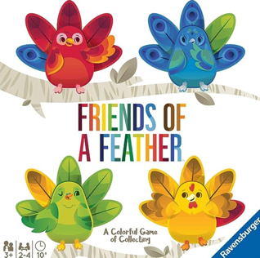 | Children can sort or compare objects around the house. Socks can be sorted by color, type, size, owner. Doing these types of activities teaches your child to pay attention to details and think about an object from different views.
- Uses senses to explore and understand their social and physical environment  - Identifies sense organs  - Begins to use senses to observe and experience the environment | Explore an apple using their five senses.  The children will:  Look at the apple and describe it.  Taste the apple and describe it.  Feel the apple and describe it.  Touch the apple and describe it.  Bite the apple and listen to it. | Cooking activities are great for exploring their world with their senses.
- PK.M.HP.4 Begin to name and distinguish right (good) from wrong (sinful) actions.  - PK.M.HC.2 Begin to understand the word sin referring to when we hurt others and don't listen to God.  - PK.M.SE.CD.4 Understand that there are good and bad choices.  - PK.M.SE.CD.5 Understand that it is alright to say "No". | Introduce the story of Adam and Eve by reading a story and singing a song. | Talk with your child about their choice, good versus poor. Talk about how all choices have consequences. Remind them that the Character Kids make good choices by being Kind, Cooperative, Brave, Honest and Responsible.
Parent Resources: For the next 8 weeks, we will be using our senses to explore apples, pumpkins, corn, spices/herbs, chalk and flowers. Our Faith Formation Story will be Adam and Eve. We will be discussing good verses poor choices and that our choices have consequences. The Character Kids will be used as examples of good choices.

