Taylor Fussell Senses Unit 10-2-23/11-24-23 Week of 10-23-23 Touch
Standard | Activity | Home Extension
Mathematical Thinking  Standards F. Measurement and Weight: 8-18 months1. Explores and shows awareness of the size and weight of object with adult assistance 18-24 months F. Measurement and Weight: 1. Uses appropriate size words or gestures (small, big) to describe objects accurately. | 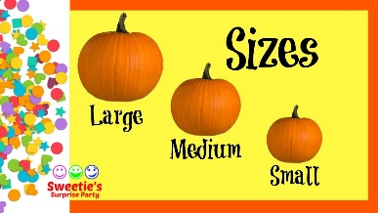  Use sense of Touch to determine the weight of object in the classroom by picking them up and sorting them according to size Model size words when children are beside each other (e.g., “Margaret is taller that Simon.”) | Have children pick up items at home and sort into heavy and light piles.
Physical Development:  Fine Motor Standard I. Physical Dev. C. Fine Motor: 2. Increasingly coordinates hand and eye movements to perform a variety of actions with increasing precision. 8-18 months Benchmark a. Coordinates the use of arms, hands and fingers to accomplish tasks. 18-24 months: Benchmark a. Uses hand-eye coordination when participating in routines, play and activities (e.g., painting at an easel, putting objects into shape sorter, putting blocks into defined space, tearing paper) | 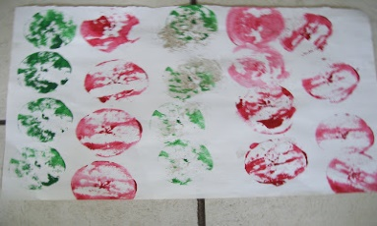  This Photo by Unknown Author is licensed under CC BY-SA-NC  Painting with Apple halves, Using the shape sorter | Have fun tearing up old newspapers with your children. The pinching and tearing of paper into little bits develops fine motor muscles and grip.
Scientific Inquiry through Exploration and Discovery1. Uses senses to explore and understand their social and physical environment. Benchmark a. Begins to identify some sense organs. Benchmark b.  Explores the nature of sensory materials and experiences (e.g., different textures, sounds, tastes and wind) | 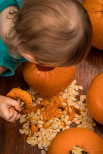  Exploring the inside of a pumpkin. Children will help empty the contents of a pumpkin and use them for art! | Carve a pumpkin at home with our child and let them help pull out and feel the gooey stuff and seeds!

