Taylor Fussell Senses Unit 10-2-23/11-24-23 Week of 10-30-23 Taste
Standard | Activity | Home Extension
Self- Help/Health  Standard: Physical Dev. Feeding and Nutrition : 1. Responds to feeding or feeds self with increasing efficiency and demonstrates increasing interest in eating habits and making food choices .8-18 months: Benchmark b. Shows interest in new foods that are offered. 18-24 months: Benchmark b. Shows willingness to try new foods when offered on multiple occasions. | - Taste Different types of Apples in applesauce, apple pie, apple slices.  Ask children which of the Apple items they like or did not like. | Offer a variety of foods to your children weekly to expand their food pallet and learn to try new experiences. Chart which foods they liked and did not and reoffer those food again in a month.  https://feedinglittles.com/offer-the-rainbow/
Social and Emotional Development  Standard: C Building and Maintaining Relationships with adults and peers 8-18 months 4. Exhibits empathy by demonstrating care and concern for others. Benchmark a. Notices the emotions of others and responds in a manner that shows understanding of that emotion (e.g., smiles when another child is happy, looks concerned when a child is sad) 18-24 months Benchmark a.  Notices the emotions of others and engages in an intentional action in response. | Sense of Right and Wrong. Develop Empathy for others. Role playing and adult modeling of appropriate response to others.  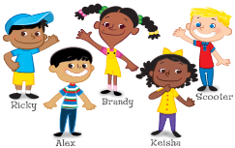  Read “No David!” Discuss the pictures with the children and talk about why David should not do the things he is doing.  Talk about the Character Kids and playing kind and responsible. | Discuss why some actions are ok and some are not and explain why. Discuss what a consequence is when we make the wrong choice and what the consequence or reward is when we make the correct choice.
Sensory-  Standard A. Scientific Inquiry through Exploration and Discovery1. Uses senses to explore and understand their social and physical environment. Benchmark a. Begins to identify some sense organs. Benchmark b.  Explores the nature of sensory materials and experiences (e.g., different textures, sounds, tastes and wind) | 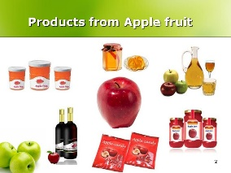  Apple Exploration – hold and feel whole apples, apple halves, applesauce, dried apples. | Let your child explore the food that they eat with their five senses.  https://feedinglittles.com/offer-the-rainbow/

