Standard | Activity | Home Extension
Sensory- Standard A. Scientific Inquiry through Exploration and Discovery1. Uses senses to explore and understand their social and physical environment. Benchmark a. Begins to identify some sense organs. Benchmark b. Explores the nature of sensory materials and experiences (e.g., different textures, sounds, tastes and wind) | Herb scents exploration- Smell different herbs and spices and compare.  Chart answered of favorite scents.  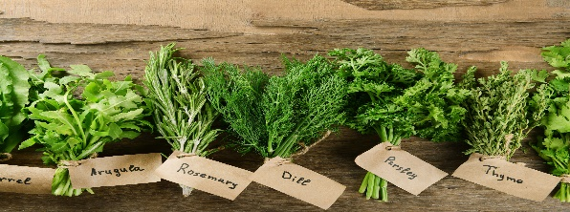 | Take a nature walk and smell the different flowers, grass, and trees.
Creative Expression- Standard: A. Sensory Art Experience 8-1. Chooses from a wide variety of open-ended, diverse and process-oriented sensory materials to engage in the art experience. | Apples and Pumpkin and Scents exploration. Paint with scented paints | Provide safe accessories for exploration. Ask for input from children regarding choices for their creations. Provide non-toxic art media. Observe and support children’s process. Describe what children are doing as they experience the art project.
Gross Motor: Standard (Sensorimotor)1. Uses perceptual information to guide motions and interactions with objects and other people Benchmark b. Begins to demonstrate awareness of own body in space Benchmark c. Begins to coordinate perceptual information and motor actions to participate and play in daily routines (e.g., singing songs with hand motions or rolling ball) | 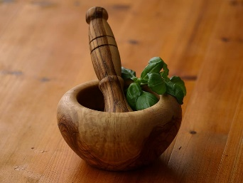  Children will use wooden blocks to release the scent. Compare different smells. Place the herbs and spices in sensory bottles for independent exploration. | Play catch with a soft ball. Practice catching, throwing, and rolling the ball across various distances.
Taylor Fussell Senses Unit 10-2-23/11-24-23 Week of 11-6-23 Smell

