Taylor Fussell Senses Unit 10-2-23/11-24-23 Week of 10-16-23 Hearing
Standard | Activity | Home Extension
Language and Literacy  B. Speaking 8-18 months1. Speaks and is understood when speaking Benchmark, a. Increases vocalizations.18-24 months Benchmark a. Speaks using new words and phrases and is understood by familiar adult 50 percent of the time. | Sing songs and tell or read stories to children. Encourage children to ask questions by asking them questions throughout the day. Provide props in dramatic play areas that encourage conversations, such as toy phones, books, puppets, dress up clothes.  ( See 5 Little Apple fingerplay on back of page) | Use labeling as a way to expand your child’s vocabulary. Give the makes of everyday objects in your house such as light switch, trash bin, wooden spoon, stove, shelf, etc.
Scientific Inquiry  Standard: E. Environment 8-24 months 1. Demonstrates awareness of relationship to people, objects and living/non-living things in their environment Benchmark a. Begins to identify familiar people and objects in the environment. | 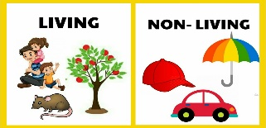  - Use senses to determine living and nonliving things in the environment. Apple vs. Ball, Tree vs. Piece of wood. Introduce living plants into the environment in the garden outside and a small nontoxic plant in the classroom such as basil. Read and discuss books about plants and animals. | Use everyday items and plants in your home to explain and show children the difference between living and nonliving items. Encourage your child to use their sense to tell the difference.
Approaches to learning : Persistence: 1. Pays attention for longer periods of time and persists at preferred activities. | 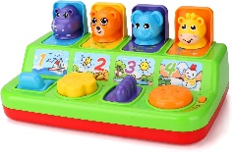  Puzzles and cause and effect toys | Use cause and effect toys and activities to engage children’s attention for longer periods of time.

