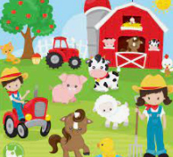
Peek at Our Week
Standard Focus | Activity | Home Extension Activity
IV. LANGUAGE AND LITERACY  F. EMERGENT READING  3. Shows alphabetic and print knowledge  IV. F. 3. a. Recognizes that print conveys meaning  C. VOCABULARY  1. Shows an understanding of words and their meanings (receptive)  IV. C. 1. a. Demonstrates understanding of age-appropriate vocabulary across many topic areas and demonstrates a wide variety of words and their meanings within each area (e.g., world knowledge) | 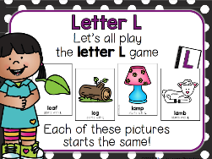  Our letter this week is "Ll"  Farm Vocabulary  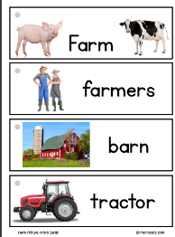 | Vocabulary:  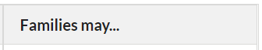Ask children to fill in words when reading together which supports children’s confidence and vocabulary.
V. MATHEMATICAL THINKING  F. MEASUREMENT AND DATA  V. F. 2. Identifies measurable attributes (such as length and weight and solves problems by making direct comparisons of objects) | 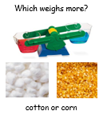  Weighing and compairing cotton balls and corn. | Florida Office of Early Learning:  If near water (e.g., a pond, river or the sea), skip rocks into the water, talking back and forth about how differences in the shapes and sizes of the rocks affect how they skip. If near a big puddle, families can do a similar experiment with rocks, sticks or leaves.
A. CULTURE  VII. A. 4. Explores cultural attributes by comparing and contrasting different characteristics (e.g., language, literature, music, arts, artifacts, foods, architecture and celebrations) | 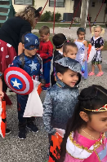  Sacred Heart’s “Box of Treats” Halloween Parade and Party on Tuesday, October 31 | Teach children family traditions and make traditions an important part of their lives,

Other News: Thank you, thank you for all the treats and party items!! We truly appreciate your generosity and support! The children have been having so much fun talking and learning about apples, pumpkins, Halloween, owls, spiders, and bats! Now, we will focus on learning about Fall and Thanksgiving.

