Peek at Our Week
Standard Focus | Activity | Home Extension Activity
IV. LANGUAGE AND LITERACY  F. EMERGENT READING  3. Shows alphabetic and print knowledge  IV. F. 3. c. Names letters (e.g., when shown an uppercase or lowercase letter, can accurately say its name)  2. Shows age-appropriate phonological awareness  IV. F. 2. a. Distinguishes individual words within spoken phrases or sentences | 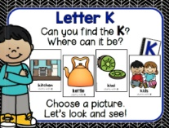  Our letter this week is "Kk”  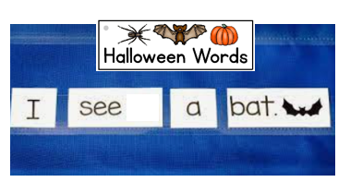 | Florida Office of Early Learning:  - Play with children by clapping, tapping, jumping or stomping one time for each syllable in a word, or individual words within spoken phrases or sentences
A. SCIENTIFIC INQUIRY  B. LIFE SCIENCE  1. Demonstrates knowledge related to living things  VI. B. 1. c. Understands that all living things grow, change and go through life cycles  These last 3 weeks we have been discussing animal and plant lifecycles. | 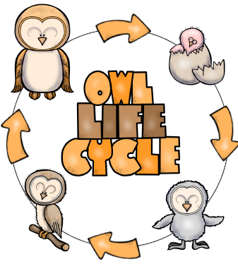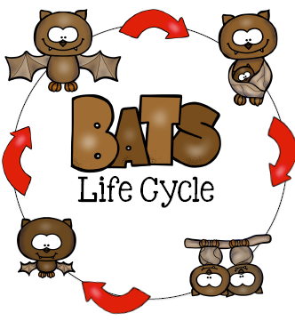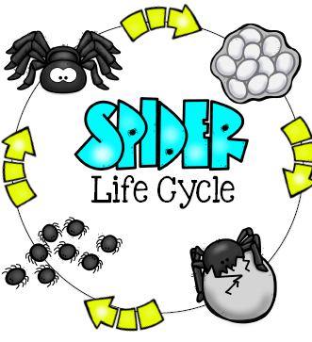  Life Cycles of Bats (mammal),  Owls (bird), and Spiders (arachnid) | Florida Office of Early Learning:  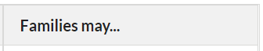  - Read books with children about plants and animals and life cycles. All living things go through a life cycle.
V. MATHEMATICAL THINKING  A. NUMBER SENSE  V. A. 5. Constructs and counts sets of objects (one to 10 and beyond) | 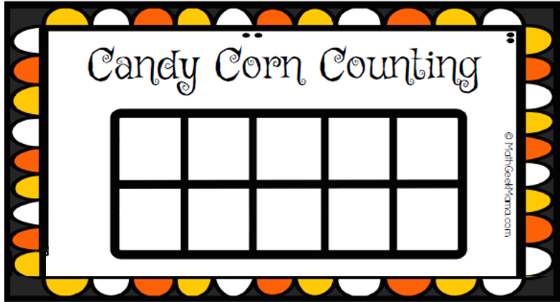 | Florida Office of Early Learning:  - Ask for children’s help in distributing items like snacks, or in laying napkins out on the dinner table (e.g., one napkin per plate).

