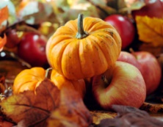
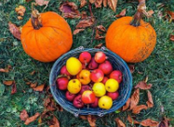
Peek at Our Week
Standard Focus | Activity | Home Extension Activity
IV. LANGUAGE AND LITERACY  F. EMERGENT READING  3. Shows alphabetic and print knowledge  IV. F. 3. b. Recognizes letters when named (e.g., when shown a group of letters, can accurately identify, verbally or nonverbally, the letter that is named)  IV. F. 3. d. Recognizes some letter sounds (e.g., when shown a group of letters, can accurately identify, verbally or nonverbally, the letter of the sound given) | 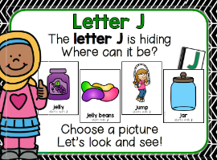  Our letter this week is "Jj”  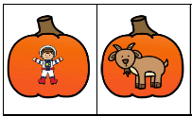  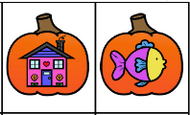  Pumpkin  Beginning  Sounds | Florida Office of Early Learning:  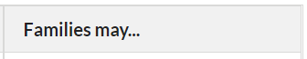  - Teach children to match the letters in their names with the sounds in their names.
A. SCIENTIFIC INQUIRY  1. Uses senses to explore and understand their social and physical environment  VI. A. 1. b. Begins to identify and make observations about what can be learned about the world using each of the five senses  B. LIFE SCIENCE  1. Demonstrates knowledge related to living things  VI. B. 1. c. Understands that all living things grow, change and go through life cycles | 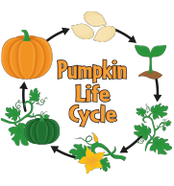  Pumpkin Life Cycle  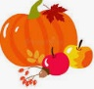  Compare and Contrast | When you carve a pumpkin to make it into a Jack-o-latern, look and explore the inside and outside of the pumpkin. Also, cut open an apple and compare it to a pumpkin. Compare and discuss the similarites and differences of the two fruits.
V. MATHEMATICAL THINKING  D. GEOMETRY  V. D. 1. Recognizes and names two-dimensional shapes (circle, square, triangle and rectangle) of different size and orientation | 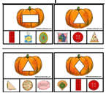  Matched to real world shapes | Florida Office of Early Learning:  - When setting the table for a meal, encourage children to think of different ways to fold napkins or paper towels to make different shapes and sizes by saying, “What shapes can you make? What does this shape look like? What would happen if you kept folding the corners down?”

Other News: Please donate a bag of peanut free treats for our Halloween Parade on Tuesday, October 31st. Please bring in Halloween items by Friday, October 27th.

