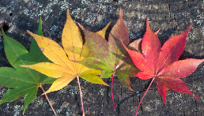
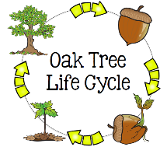
Peek at Our Week
Standard Focus | Activity | Home Extension Activity
IV. LANGUAGE AND LITERACY  F. EMERGENT READING  3. Shows alphabetic and print knowledge  IV. F. 3. a. Recognizes that print conveys meaning  2. Shows age-appropriate phonological awareness  IV. F. 2. d. Combines syllables into words (e.g., “sis” + “ter” = “sister”) | 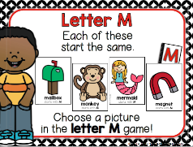  Our letter this week is "Mm"  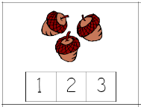  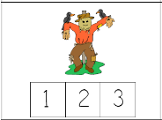  Counting  Syllables  In Fall Words | 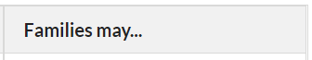  - Collect some small household items (pencil, block, cookie, toothpaste, cup, etc.) or pictures and place them in a box or small bag. The adult removes one item, says its name and asks children how many “claps” it has. Say the object name again, clapping as the adult says each syllable. Then it is the children’s turn to take an item out of the box, say the name and clap the syllables.
A. SCIENTIFIC INQUIRY  B. LIFE SCIENCE  1. Demonstrates knowledge related to living things  VI. B. 1. b. Notices the similarities and differences among various living things | 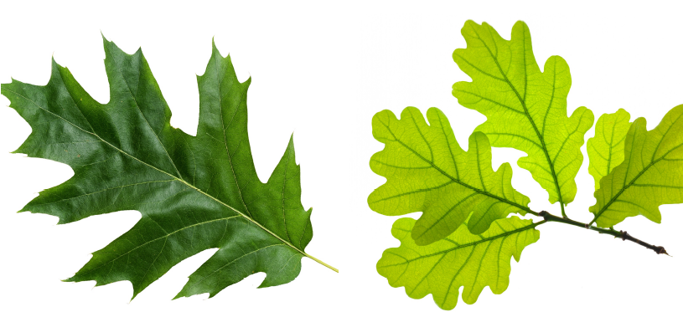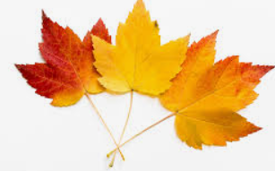  Oak leaves Maple leaves | - Give children two different kinds flowers (or leaves) and ask them to tell how they are alike and different.
V. MATHEMATICAL THINKING  A. NUMBER SENSE  V. A. 2. Counts and identifies the number sequence “1 to 31” | 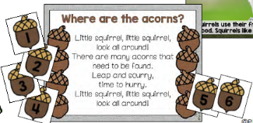  Finding numbered “acorns” and then placing them in numerical order. | - Play number games with children by rolling dice or use a number card, move that many spaces.

