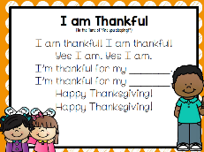
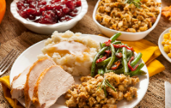
Peek at Our Week
Standard Focus | Activity | Home Extension Activity
IV. LANGUAGE AND LITERACY  F. EMERGENT READING  2. Shows age-appropriate phonological awareness-Listens and matches rhythm, volume and pitch of rhymes, songs and chants  3. Shows alphabetic and print knowledge  IV. F. 3. a. Recognizes that print conveys meaning | 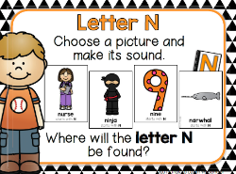  Our letter this week is Nn”  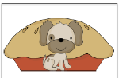  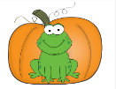  Pumpkin Pie  Rhyming | Florida Office of Early Learning:  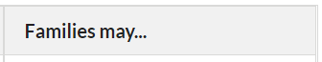  - As you read and reread books that rhyme, encourage your child to finish rhyming lines in the books read aloud.
VII. SOCIAL STUDIES  G. ECONOMICS AND RESOURCES  VII. G. 1. Recognizes the difference between wants and needs | 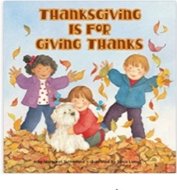 | - Acknowledge children’s requests for things that are not a current need or priority such as (e.g., “I know you really want to go to the park, but we do not have time to stop right now because we need to go to the grocery story.” or “I can see you really want to buy that book. Let’s go to the library next week and see if we can borrow it instead of buying it.”).
V. MATHEMATICAL THINKING  D. GEOMETRY  V. D. 3. Creates two-dimensional shapes using other shapes (e.g., putting two squares together to make a rectangle) | 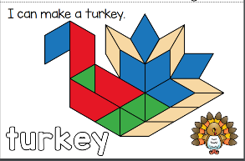 | - Cut a cereal box into different shapes. Children can put them together in different ways to make different things, or sort shapes by how many sides they have.

We hope you have a blessed and wonderful Thanksgiving celebration with your family next week!

