Alex Classen VPK Full
October 1st, 2023 – October 7th, 2023
Unit: Senses Peek at Our Week
This Photo by Unknown Author is licensed under CC BY-NC
Standard Focus | Activity | Home Extension Activity
Scientific Inquiry  A. SCIENTIFIC INQUIRY THROUGH EXPLORATION AND DISCOVERY  1. Uses senses to explore and understand their social and physical environment  Benchmark a.  Identifies each of the five senses and their relationship to each of the sense organs | Children will explore an Adam and Eve sensory bin.  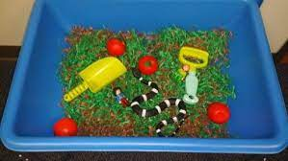 | Play mystery sock. Put a common household item in a sock. Tie off the top of the sock. Have your child feel the sock, and guess what is inside. Take turns guessing what is inside.
Social & Emotional  C. BUILDING AND MAINTAINING RELATIONSHIPS WITH ADULTS AND PEERS  2. Develops positive relationships with peers.  Benchmark b.  Maintains friendships and is able to engage in prosocial behavior such as cooperating, compromising and turn-taking. | The children will participate in telling the story of the Square Pumpkin.  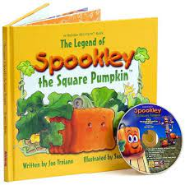 | Provide age-appropriate choices to help children make decisions.
Mathematics  C. PATTERNS  1. Identifies and extends a simple AB repeating pattern. | The children will attempt to make patterns resembling tacos for taco day (Taco colors, building tacos, etc.) | Have children collect items like rocks and leaves on a walk. Arrange them in a pattern such as one rock, two leaves, one rock, two leaves. Then mix them up and ask the children to recreate the pattern. Can they remember the order? Have children take a turn making a simple pattern for the adult to remember.

