Alex Classen VPK Full
November 19th, 2023 – November 25th, 2023
Unit: SENSES Peek Of Our Week
Standards | Activity | Home Extension
Approaches to Learning  B. PERSISTENCE  1. Attends tasks for a brief period of time. | The children will discuss what holiday is coming up and make their favorite thanksgiving food with playdoh.  This Photo by Unknown Author is licensed under CC BY-NC | Make a book with children. Think about a topic that they are interested in and help them write a story about it. Ask children to draw pictures and help them write words on the page. Read the story together.
Language & Literacy  F. EMERGENT READING  2. Shows age-appropriate phonological awareness | The children will identify vowel sounds, vowel letters, and the vowels in their names.  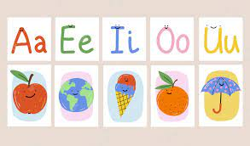 | Read and reread with children books that rhyme.
Social Studies  3. Demonstrates awareness of group rules (e.g., family, classroom, school, or community) | The children will work together to mix and bake cookies. They will practice taking turns cutting different shapes and decorating them. | Encourage children to invent a game and create their own rules. Have children teach the game to someone.

