Alex Classen VPK Full
November 12th, 2023 – November 18th, 2023
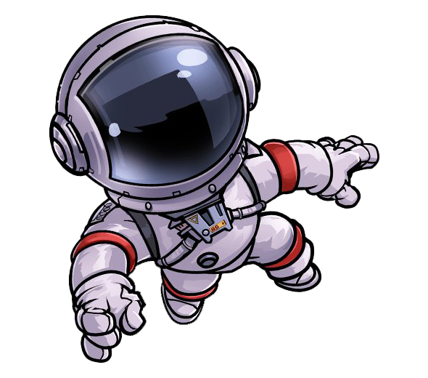
Unit: SENSES PEEK OF OUR WEEK
This Photo by Unknown Author is licensed under CC BY-NC
Standards | Activity | Home Extension
Creative Expression  E. APPRECIATION OF THE ARTS  2. Compares own art to similar art forms. | The children will cut out pictures from magazines and practice gluing them on paper.  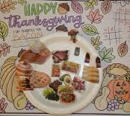 | Visit an art museum or a children’s museum and encourage critical thinking by asking, “What do you think the artist was thinking about when he painted this picture?”
Mathematics  2. Describes, sorts and classifies two- and three-dimensional shapes using some attributes such as size, sides and other properties (e.g., vertices) | The children will play a matching game with “cookies” and number matching.  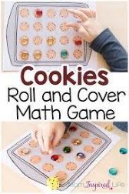 | Play the shape game; collect a variety of two-dimensional shapes and place them in the bag for children to feel and describe before pulling them.
Social & Emotional  4. Exhibits empathy by demonstrating care and concern for others  Benchmark a.  Able to take the perspective of others and actively respond in a manner that is consistent and supportive | Children will explore their sense of sight by showing kindness to friends and deciding who gets to take the first turn.  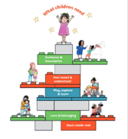 | Read stories to children about friends.

