Alex Classen VPK Full
November 5th, 2023 – November 11th, 2023
Unit: SENSES PEEK OF OUR WEEK
Standards | Activity | Home Extension
Approaches to Learning  A. EAGERNESS AND CURIOSITY  1. Shows increased curiosity and is eager to learn new things and have new experiences. | The children will explore different scented paints and paint what they smell. | Go on a nature walk. Parks and backyards are filled with natural materials that can be used for art projects. Ask children to describe the things they have found: “What do you see? What does it feel like? What does it smell like?”
Physical Development  2. Increasingly coordinates hand and eye movements to perform a variety of actions with increasing precision | Children will attempt to mix their own seasonings to take home.  This Photo by Unknown Author is licensed under CC BY-NC  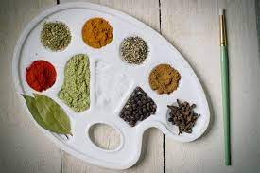 | Complete some outdoor chores as a family while reaching, pulling, pushing and bending.
Creative Expression  E. APPRECIATION OF THE ARTS  1. Uses appropriate art vocabulary to describe own art creations and those of others. | The children will make Veterans Day cards in preparation for Veterans’ Day.  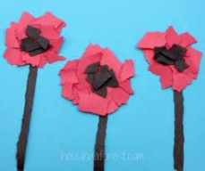 | Read wordless picture books (e.g., Pancakes for Breakfast by Tomie DePaola and Rosie’s Walk by Pat Hutchins) and allow children to examine the pictures and come to their own conclusion about the story being told.

