Alex Classen VPK Full
October 29th, 2023 – November 4th,2023
Unit: SENSES PEEK OF OUR WEEK
Standards | Activity | Home Extension
Social Studies  4. Explores cultural attributes by comparing different characteristics (e.g., language, literature, music, arts, artifacts, foods, architecture, and celebrations). | Children will participate in a Halloween Parade and class party with their fellow classmates.  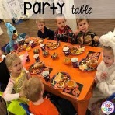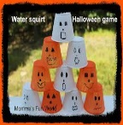 | Grow different and unfamiliar flowers and vegetables in the house, or in a community garden.
Mathematics  F. MEASUREMENT AND DATA  1. Measures object attributes using a variety of standard and nonstandard tools. | Children will learn to measure by using their sense of sight, measuring tools, and their sense of taste when creating their doughnut balls.  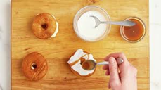 | Use nonstandard measuring tools, including paper strips, straws, pieces of yarn and plastic spoons and cups.
Physical Development  d. Feeding and Nutrition  1. Responds to feeding or feeds self with increasing efficiency and demonstrates increasing interest in eating habits and making food choices | The children will be provided with opportunities to help prepare or sample healthy and nutritious foods.  This Photo by Unknown Author is licensed under CC BY-NC  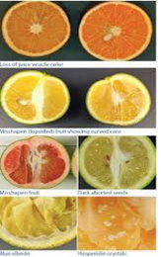 | Have children explore how certain foods clean our teeth (apples) or make our teeth sticky/dirty (marshmallows).

