Alex Classen VPK Full
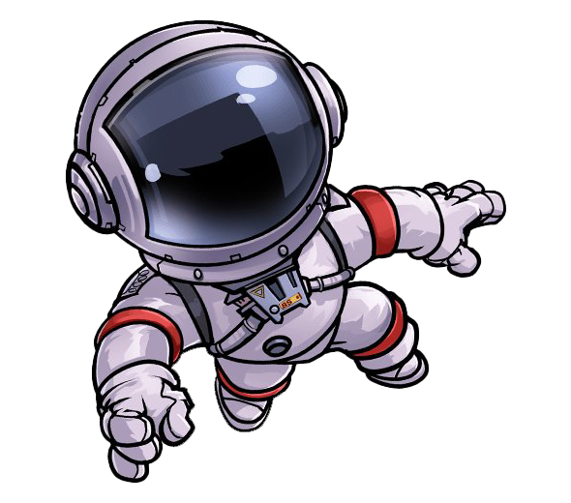
October 22nd, 2023 – October 28th, 2023
This Photo by Unknown Author is licensed under CC BY-NC
UNIT: SENSES PEEK OF OUR WEEK
Standards | Activity | Home Extension
Social & Emotional  C. BUILDING AND MAINTAINING A RELATIONSHIP WITH ADULTS AND PEERS  2. Develops positive relationships with peers  Benchmark a.  Plays with peers in a coordinated manner including assigning roles, materials and actions. | The children will explore a mystery box and identify what texture they are feeling.  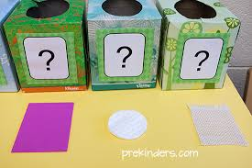 | Include children in household chores (e.g., picking up toys, setting the table, sorting socks).
Social Studies  - Culture  4. Explores cultural attributes by comparing and contrasting different characteristics (e.g., language, literature, music, arts, artifacts, foods, architecture and celebrations). | The children will use brave talk to describe the pumpkins that they decorated.  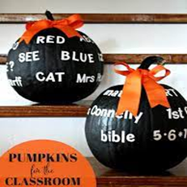 | Encourage children to listen to classmates’ experiences and stories, share their own and find similarities.
Creative Expression  A. SENSORY ART EXPERIENCE  1. Combines with intention a variety of open-ended, process-oriented and diverse art materials. | The children will explore conditioner mixed with food dye to paint a picture with sticks.  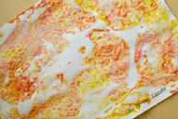 | Visit children’s museums or art museums.

