Alex Classen VPK Full
October 15th, 2023 – October 21st, 2023
Unit: Senses Peek at Our Week
This Photo by Unknown Author is licensed under CC BY-NC
Standard Focus | Activity | Home Extension Activity
Social Studies  - Culture  3. Explores culture of peers and families in the classroom and community. | ST. LUKE’S FEAST DAY  The children will learn about St. Luke being the patron saint of artists, and doctors. The children will make their own ice cream using salt, vanilla extract, ice, granulated sugar, and half & half. ***Kids with special allergies to bring special milk for ice cream*** | Encourage children to listen to classmates’ experiences and stories, share their own and find similarities.
Physical Development  c. Fine Motor Development  1. Demonstrates increasing precision, strength, coordination and efficiency when using hand muscles for play and functional tasks. | The children will use pasta and string to make snakes and trees from our Adam and Eve story.  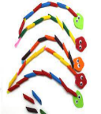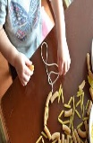 | Make homemade playdough for children to manipulate and make creations. Allow children to practice slicing, cutting and rolling with age-appropriate tools.
Scientific Discovery  A. SCIENTIFIC INQUIRY THROUGH EXPLORATION AND DISCOVERY  1. Uses senses to explore and understand their social and physical environment.  Benchmark b.  Begins to identify and make observations about what can be learned about the world using each of the five senses. | The children will use hearing to identify sounds we hear when making a pumpkin volcano using baking soda and vinegar.  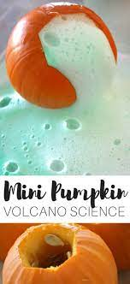 | Challenge children to use their senses to complete specific tasks (e.g., use sight to locate something pink in the classroom; use smell to show where the scented candle is; use taste to determine your favorite food at lunch; use hearing to know when to clean-up; use touch to find a specific toy without looking).

