Alex Classen VPK Full
October 8th, 2023 – October 14th, 2023
Unit: Senses Peek at Our Week
Standard Focus | Activity | Home Extension Activity
Approaches to Learning  A. EAGERNESS AND CURIOSITY  1. Shows increased curiosity and is eager to learn new things and have new experiences. | The children will explore the sensory table garden of Edin.  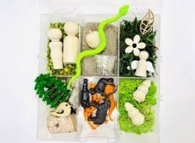 | Explore the backyard by giving children a small area to dig in the dirt. Use a small shovel or gardening tools. Have children look for plants, rocks, insects, seeds and anything else they can find and then talk about the items.
Language & Literacy  A. Listening and Understanding  2. Increases knowledge through listening | The children will learn the letters Q and R and what sounds they make. | Play games that require careful listening (e.g., “Simon Says”).
Scientific Discovery  A. SCIENTIFIC INQUIRY THROUGH EXPLORATION AND DISCOVERY  1. Uses senses to explore and understand their social and physical environment.  Benchmark b.  Begins to identify and make observations about what can be learned about the world using each of the five senses. | The children will make donuts and be able to identify using sight to identify changes happening in the dough. | Challenge children to use their senses to complete specific tasks (e.g., use sight to locate something pink in the classroom; use smell to show where the scented candle is; use taste to determine your favorite food at lunch; use hearing to know when to clean-up; use touch to find a specific toy without looking).
This Photo by Unknown Author is licensed under CC BY-NC

