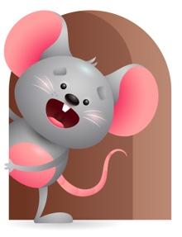
Peek at Our Week

Standard Focus | Activity | Home Extension Activity
Social Studies-Younger- Responds and recognizes people and objects. Older- Time, continuity and change- begins to respond to schedules. | Younger- pick up different objects and name them. Play a game where is (child’s name) I don’t know. (use Mommy and Daddy too). Older- Through repetition talk to them and say we had our morning snack-it is time to go outside- Nap is over-it is lunch time. | Younger- through the day show them pictures and tell them what or who it is- name different objects in the house- table-chair-bed. Older- through the day tell them it is Play Time-Lunch-Nap-outside- time to go to the store.
Mathematical Thinking-Younger- Explores objects in hands. Older-Observes songs and finger plays with numbers. | Younger- Let them explore the blocks in their hands while you stack them and count to 3. Older-Do finger plays- here is the beehive- 5 little monkeys- 5 green and speckled frogs-use hand puppet. | Younger- While using their senses count the objects you give them to explore in their hands. Older- do some simple finger plays that involves numbers.
Scientific Inquiry- Younger- Uses senses to explore and understand their social and physical environment. Older- Displays interest in movement of objects. | Younger- let them explore different textures with you and read the touch and feel books. Older- watches an object move and is curious why it stopped. Play with the cars and roll them back and forth to each other. | Younger- give them different textured materials and objects and let them explore them using their senses. Older- let them watch objects move and stop-show them how they work.

Parent Resources

Other News- This week is Ricky- He is Honest. Try to show them that when they take a toy from their friend, they need to give it back because it was their turn to play with it. Ask them to wait their turn and share. Show them how.

Faith Formation- “Let there be land animals. Let us make man in our image”

