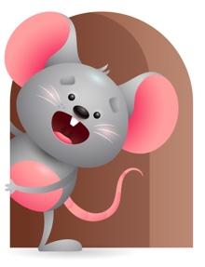
Peek at Our Week

Standard Focus | Activity | Home Extension Activity
Language and Literacy-Younger- Uses consonant like sounds. Older- Shows an understanding of words and their meaning. | Younger- Sing old McDonald had a farm and make the sounds of the animals. Older- Read God made animals and name all the objects you see and make the animal sounds. Ask them to make the sounds with you. | Younger- Read to your child and name the objects in the book and do the sounds of things you see. They will start to make sounds like babbling. Older- Read books to them and ask them can you make this sound. Pick something out of the book and ask them to repeat it after you.
Physical Development-Younger- Demonstrates use of large muscles for movement, position, strength, and coordination. Older- Uses each new posture to learn new ways to explore the environment | Younger- Practices rolling over, crawling, and sitting. While playing with the pop-up toy they practice pushing the knob that makes it pop up. Older- Practices crawling to get from one place to another- sits to play and reach for things. Pulls up to stand. Hold them up and help them to take their first steps. | Younger- let them play with toys that will strengthen their muscles and help their coordination. - squeeze toys- rattles to shake- building blocks. Older- While playing put toys away from them so they will have to move or reach to get them. Work with them to help them take their first steps.
Approaches to Learning-Younger- Persistence-attends to things for brief and increasing periods of time. Older- Creativity and Inventiveness. | Younger- Explore the toys and see what sounds they make and what they do. Continue to play with cause-and-effect toys to practice pushing it and making it work. Older- Build with blocks and see how many will fit together before falling. | Younger- Continue to let them explore toys to see what sounds they make and what they do. Help them to have interesting and pleasurable outcomes. Older- Let them fill and dump things and give them things to stack to see how many they can do.

Parent Resources

Other News- This week is Keisha- She is Responsible and Follows Directions. We will practice helping them to pick up toys and put them in a bucket while singing the clean up song. Encourage them to come to you when it is time to eat or change a diaper.

Faith Formation-He saw that all was good and he rested.

