Alex Classen VPK Full
September 17th, 2023 – September 23rd, 2023
Unit: Our Classroom Community
Peek at Our Week

Standard Focus | Activity | Home Extension Activity
Physical Development  2. Uses perceptual information to guide motions and interactions with objects and other people. | The children will use Mr. Potato Heads to match different body parts in the appropriate locations. | Dance with children to songs that give positions and directions to encourage purposeful movement. These include The Electric Slide, The Cha-Cha Slide, The Macarena, or the Hokey Pokey.
Social Studies  D.Spaces, Places, & Environments  2.Identifies differences and similarities between own environment and other locations. | 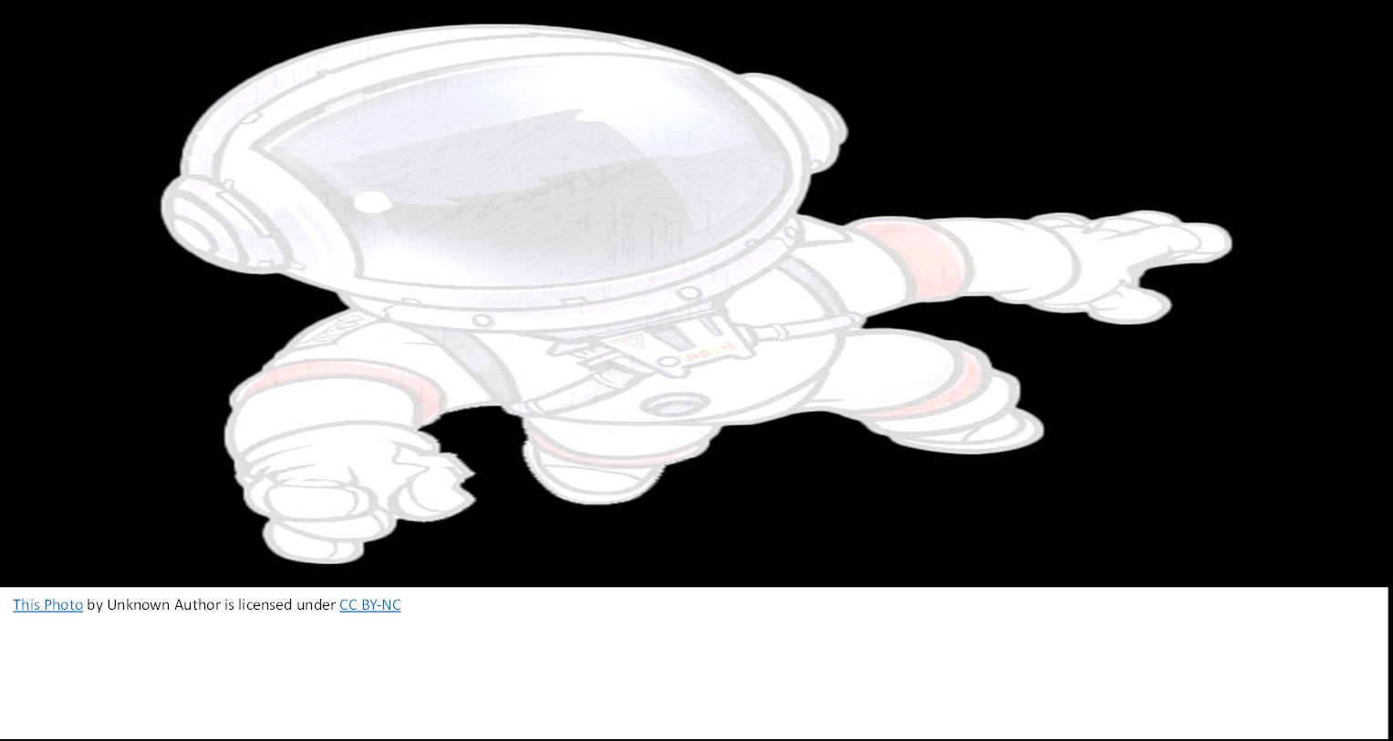  The children will follow along to the book The City Talks by Joy Dickinson. The children will discuss how we can be kind and responsible for our city. | Read fiction and non-fiction books about environments different than the one they live in and compare/contrast the environments using pictures, drawings and simple words.
Scientific Inquiry  - Scientific Inquiry Through Exploration & Discovery  2.Uses tools in scientific inquiry.  Benchmark a.  Make predictions and tests their predictions through experimentation and investigation. | The children will use Ziplock bags and cheerios (or chips) to make their own stuffing as illustrated in our book. | Ask open-ended questions such as, “I wonder what would happen if…?” Give children the opportunity to explain their ideas.

