Alex Classen VPK Full
September 10th, 2023 – September 16th, 2023
Unit: Our Classroom Community
Peek at Our Week

Standard Focus | Activity | Home Extension Activity
Creative Expression  C.Creative Movement  1.Continues to engage in individual and group movement activities to express and represent thoughts, observations, imagination, feelings, experiences, and knowledge. | The children will use play-doh to make people and land animals. | Imitate animal movements. Gallop, twirl and perform imaginative movements in response to music.
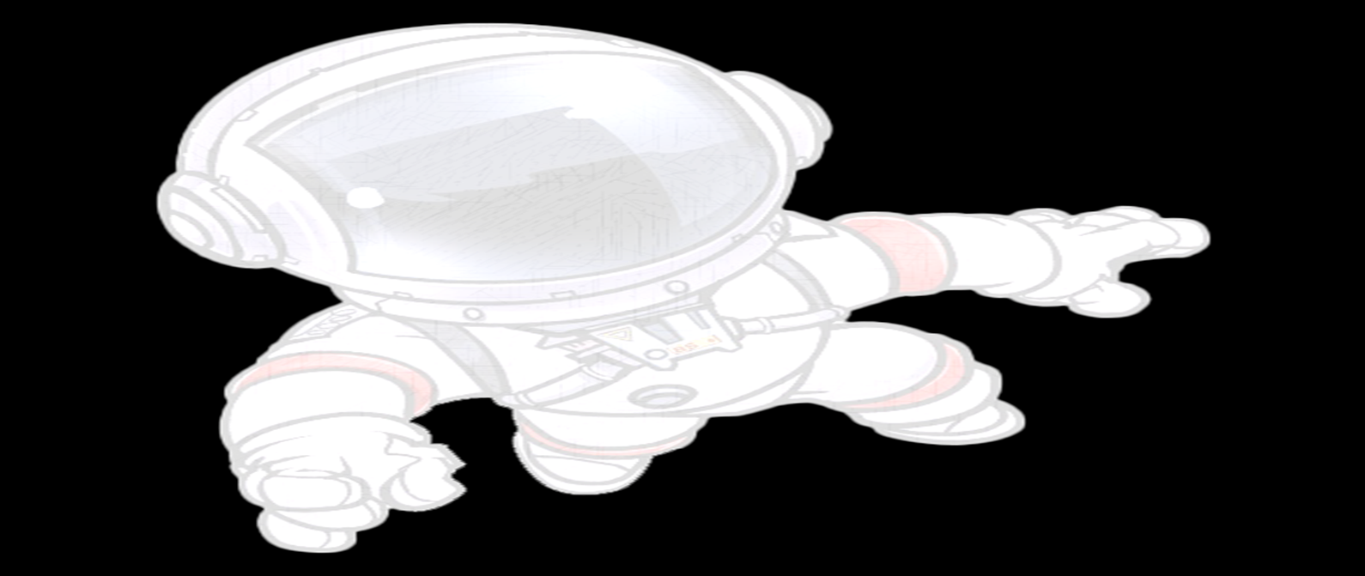  Approaches to Learning  A.Eagerness & Curiosity  1. Shows increased curiosity and is eager to learn new things and have new experiences. | The children will discuss how animals and humans are one in God’s eyes and discuss what we need to survive. | On a sunny day, have children find their shadow. Ask what makes a shadow. Explore the shape of the shadow by moving around. Trace the shadow using sidewalk chalk. Go back later in the day and check the place where you traced the shadow.
Social Studies  D.Spaces, Places, & Environments  2. identifies differences and similarities between own environment and other locations. | The children discussed the ingredients needed to adapt to make rice crispy treats, the same as God’s creatures. | During family vacations or travels away from home, ask children what objects or landmarks they see that are the same and different than what they would see at home.

