Alex Classen VPK Full
September 3rd, 2023 – September 9th, 2023
Unit: Our Classroom Community
Peek at Our Week

Standard Focus | Activity | Home Extension Activity
Scientific Inquiry  - Life Science  1.Demonstrates knowledge related to living things and their environment. | The children will explore blue Jello in a sensory bin and find different ocean animals in their “ocean water”. | Read books about animal adaptations or animal homes/habitats (e.g., animals living in different places have special features that help them to survive).
Social Studies  D.Spaces, Places, &Environments  1. Identifies the relationship of personal space to surroundings. | 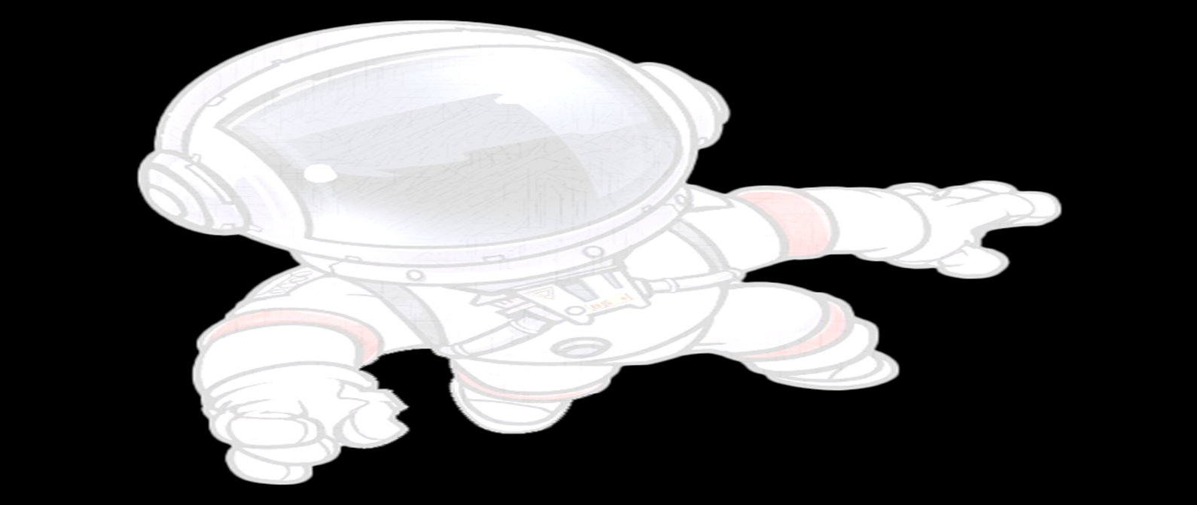  The children will use play-doh to make different birds, and ocean animals and identify each of them. | While taking a walk around the neighborhood, point out road signs and house numbers and discuss their purpose.
Mathematical Thinking  - Number Sense  4.Identifies the last number spoken tells, “how many” up to 10 (cardinally). | The children will sort ocean animals and count how many of each ocean animals there are. | Find authentic reasons to count things around the house and outdoors. Remember to ask the question, “How many?” once the counting sequence is complete.

