Alex Classen VPK Full
August 27th, 2023 – September 2nd, 2023
Unit: Our Classroom Community
Peek at Our Week

Standard Focus | Activity | Home Extension Activity
Creative Expressions  - Sensory Art Experience  1.Combines with intention a variety of open-ended, process-oriented and diverse art materials. | The children will make their own version of Vincent Van Gogh’s Starry Night. | Visit children’s museums or art museums.
Social & Emotional Development  3. Develops increasing ability to engage in social problem solving. | 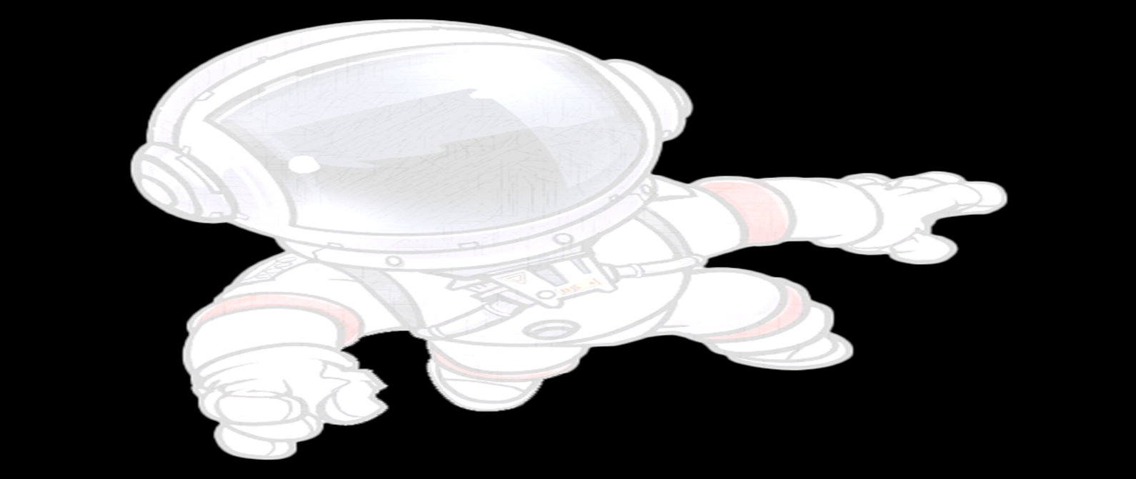  The children will explore their community and group items together matching similar characteristics together (e.g., Red items, cars, stars, round items, etc.) | Encourage children to use language to express own wants and needs.
Scientific Inquiry  - Scientific Inquiry Through Exploration & Discovery  2.Uses tools in scientific inquiry  Benchmark a.  Makes predictions and tests their predictions through experimentation and investigation. | The children will hypothesize what will happen when we put grapes in regular water versus seltzer water. | Help children make predictions about daily routines (e.g., “What would happen if we don’t brush our teeth?”).

