Alex Classen VPK Full
August 20th, 2023 – August 26th, 2023
Unit: Our Classroom Community
Peek at Our Week

Standard Focus | Activity | Home Extension Activity
Social Studies  D. Spaces, Places, & Environments  1. Identifies the relationship of personal space to surroundings. | The children will learn how things grow and what they need to grow (e.g., Trees, plants, flowers, etc.) | When driving to the store, ask children to point out recognizable landmarks (e.g., a bridge, railroad tracks, McDonald’s, etc.).
Mathematical Thinking  D. Geometry  4. Constructs with three-dimensional shapes in the environment through play (e.g., building castles in construction area) | 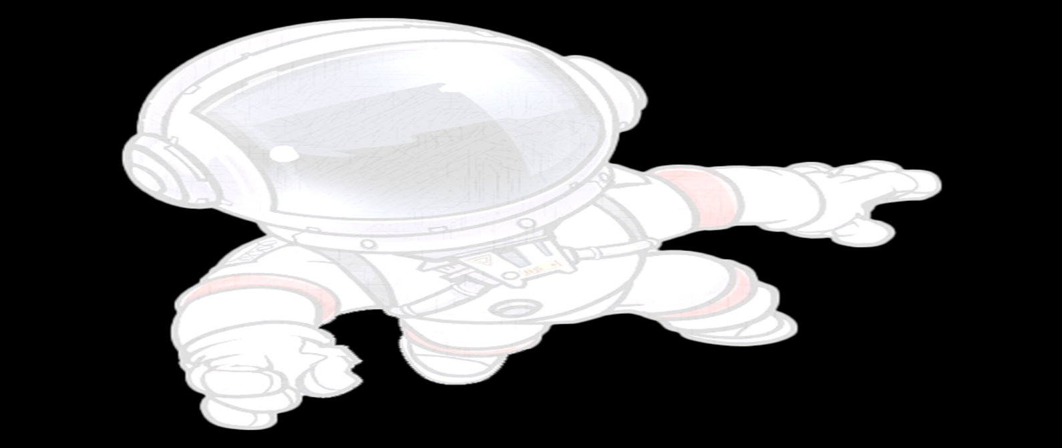  The children will use a variety of manipulatives to make different plants and trees. | Give children opportunities to play with wooden blocks, plastic interlocking blocks, empty boxes, milk cartons, etc. Stacking and manipulating these toys helps children learn about shapes and the relationships between them.
Scientific Inquiry  B. Life Science  1. Demonstrates knowledge related to living things and their environments.  Benchmark c.  Understands that all living things grow, change, and go through life cycles. | The children will experiment with pretzels, marshmallows, and sun butter to make the land and trees around them. | Plant seeds in the yard or in cups with dirt. Talk with children about how seeds need good soil, water and sunlight. Support children as they observe the plants growing and participate in their care by watering, etc.

