Alex Classen VPK Full
August 13th, 2023 – August 19th, 2023
Unit: Our Classroom Community
Peek at Our Week

Standard Focus | Activity | Home Extension Activity
Language & Literacy  2. Increases knowledge through listening.  Benchmark a.  Identifies the main ideas, some details of conversation, story or informational text and can explicitly connect what is being learned to own existing knowledge. | The children will follow along to the book Give Me 5 A Day by Kathy Reeves, Brenda Crosby, Jennifer Hemphill, & Elizabeth Hoffman. They will start to discuss what healthy eating is. | Ask everyone at the dinner table to share “news” about their day.
Approaches to Learning  D. Planning & Reflection  1. Demonstrates some planning and learning from experiences. | The children will attempt to build a house out of paper materials (e.g., paper, cards, etc.) | Play games that require planning, such as building a block wall, seeing who can match the most pairs of socks. Talk about what children are thinking.
Scientific Inquiry  D. Earth & Space Science  Benchmark b.  Discovers, explores, sorts, compares, and contrasts objects that are naturally found in the environment, including rocks, soil, sand, and mud, and recognizes relationships among the objects (e.g., rocks, twigs, leaves, seashells, etc.) | 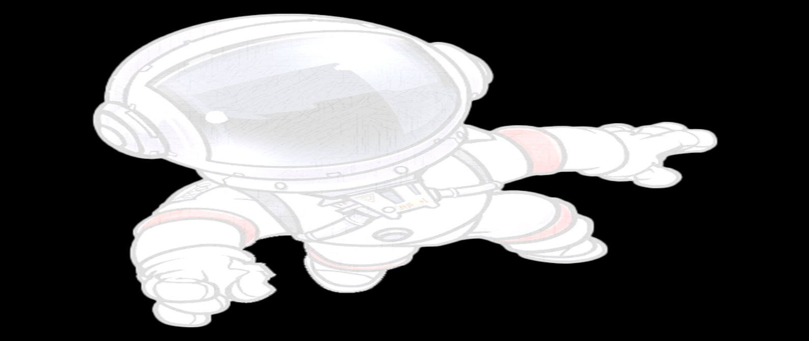  The children will have sensory play and work together to make sandcastles with our friends. | Take children on nature hikes, and allow children to make leaf/rock/shell collections.

