Alex Classen VPK Full
August 6th, 2023 – August 12th, 2023
Unit: Our Classroom Community
Peek at Our Week

Standard Focus | Activity | Home Extension Activity
Approaches to Learning  1.Shows increased curiosity and is eager to learn new things and have new experiences. | The children will hunt around the room to find the first letter of their name. | Go on a nature walk. Parks and backyards are filled with natural materials that can be used for art projects. Ask children to describe the things they have found: “What do you see? What does it feel like? What does it smell like?”
Language & Literacy  1.Demonstrates understanding when listening.  Benchmark a.  Engages in multiple back and forth communicative interactions with adults (e.g., Teacher-shared information, read aloud books, etc.) | 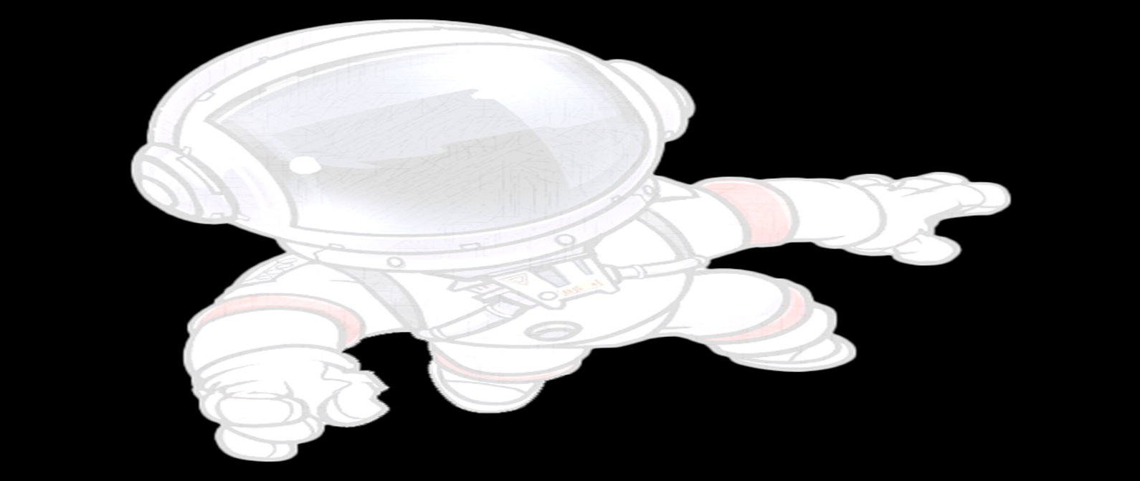  The children will listen and follow along to the book How Do Dinosaurs Go to School by Jane Yolen & Mark Teague. They will make connections between the book and themselves. | Play games that require listening and thinking (e.g., “I Spy”: “I spy something that has wings, and flies in the air and is resting on the window ledge right now!” or “Who or What Am I?”: “I come by your house every day of the week, I pick up children at the corner, I take them to school and I am yellow. What am I?”).
Mathematical Thinking  1.Explores quantities up to eight using objects, fingers, and dramatic play to solve real world joining and separating problems. | The children will practice their matching skills and counting skills with matching and counting games in small groups. | Sing and act out games that demonstrate how sets increase and decrease. Adding and subtracting will evolve and be stronger if children have many opportunities to play and explore quantities.

