Alex Classen VPK WRAP
July 30th, 2023 – August 5th, 2023
Unit: Our Classroom Community
Peek at Our Week
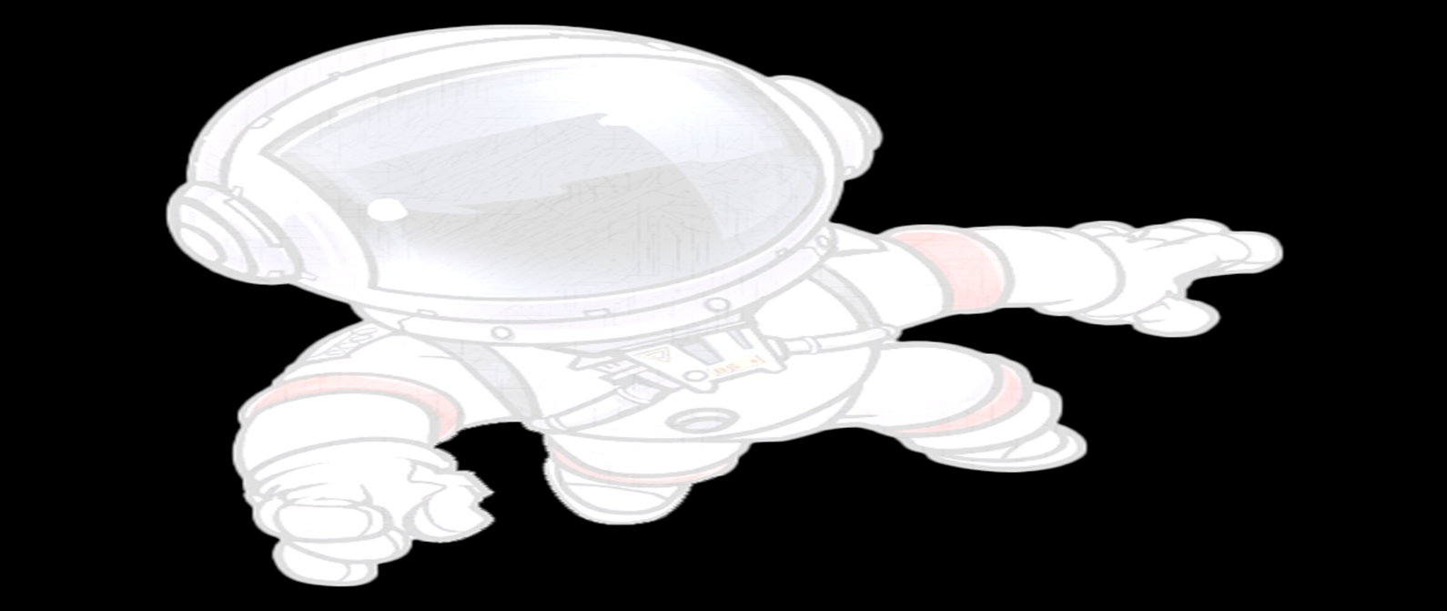
Standard Focus | Activity | Home Extension Activity
Scientific Inquiry  1. Uses senses to explore and understand their social and physical environment  Benchmark a.  Identifies each of the five senses and their relationship to each of the sense organs | The children will explore a discovery box filled with various materials that allow children to explore their senses (e.g., Smelling jars, Blindfolds, Touch Boxes, Braille Books, etc.) | Provide opportunities for children to identify how different foods taste (e.g., sweet, sour).
Social Studies  1. Identifies differences and similarities of self and others as part of a group. | The children will measure how tall they are with a variety of different materials in the classroom (e.g., Shoes, Blocks, Books, etc.) | Explain to children that differences make us unique. Some friends wear glasses, move using a wheelchair, are different sizes, skin color and wear different clothing. There are also many ways we are the same. Give examples.
Mathematical Thinking  5. Constructs and counts sets of objects (one to 10 and beyond). | The children counted how many letters are in each of their names. The children then used counting blocks to count the letters in their name. | Ask for children’s help in distributing items like snacks, or in laying napkins out on the dinner table (e.g., one napkin per plate).

