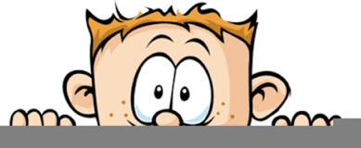

Peek at Our Week

Florida Early Learning and Development Standards | School Activity | Home Extension Activity
Scientific Inquiry  - Begins to explore materials and construct simple objects and structures and begins to explore motion and stability | 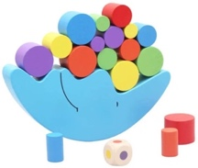  Balance/Stacking Puzzles:  In our classroom, we have a variety of these types of puzzles and games. They require persistence, the ability to learn from experience, planning, and imagination. | If you have paper or plastic cups, have your child see how many they can stack. Pick a random selection of toys and then see if you can balance them on top of each other.
Mathematical Thinking  - Begins to explore materials and construct simple objects and structures and begins to explore motion and stability (e.g., block building, ramps, pathways, sand, playdough and knocking over a block tower) | Class Tower Building Game  The class will take turns each putting a block on a tower. We will discuss waiting your turn, persistence, frustration, being cooperative and kind, | Make towers at home. Try using unusual materials such as cars, plastic animals or baby dolls. Using these materials will make the task harder and will be an opportunity to practice persistence and learn to handle frustration.
Physical Development  - Carries out some steps of own personal hygiene routines with specific adult guidance or demonstration | Finger painting and practicing thorough handwashing  The children will finger paint and then they will wash their own hands until all the paint is gone. | Intentionally plan a cooking project where your child will get their hands messy helping. Then give them time to completely wash their hands. At school we make bubble gloves with the soap and water before putting our hands under the water to rinse.

This is the last week of our Creating Our Classroom Community Unit. Can’t believe that 9 weeks have already gone by!

