Peek at Our Week

Florida Early Learning and  Developmental Standards | School Activity | Home Extension Activity
Religious Focus: Creation – Day Three  - “Let there be dry land and plants.” | 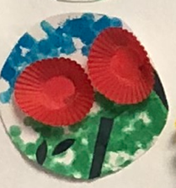  This is an example of what the children will be making to represent the creation of land and plants. | Children enjoy taking care of things, so now might be a good time to plant some flowers in a pot for your child to water and take care of.
Language and Literacy  - Demonstrates understanding when listening  - Engages in multiple back-and-forth communicative interactions with adults and peers during creative play and in purposeful and novel situations | Listening Game:  Finish my line  Ask the child to finish your sentences. You can use popular children’s songs, poems, or everyday phrases, e.g., “Twinkle, twinkle little…” | This Listening Game can be easily played at home with your favorite songs, repetitive books and phrases.
Language and Literacy  - Demonstrates understanding when listening  Social Studies  - Begins to recognize expectations in varying settings | Voice Modulation Game  Sing “I have a Soft Voice” song first using a normal tone of voice, then sing it loudly, then as a whisper, and finally using a normal soft voice again. | Play the Voice Modulation Game at home with a song you know such as Twinkle, Twinkle Little Star. Remember the goal is to teach your child how to use a soft or normal tone of voice and how to change their tone when asked to use a soft voice or a whisper or to be completely quiet.

Character Kid of the Week: Scooter, who is Kind.

