Peek at Our Week
Standard | Activity | Home Extension
IV. LANGUAGE AND LITERACY  F. EMERGENT READING  2. Shows age-appropriate phonological awareness-Listens and matches rhythm, volume and pitch of rhymes, songs and chants  3. Shows alphabetic and print knowledge  IV. F. 3. a. Recognizes that print conveys meaning | 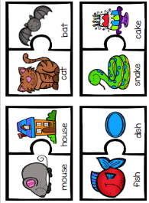  Rhyming Words | 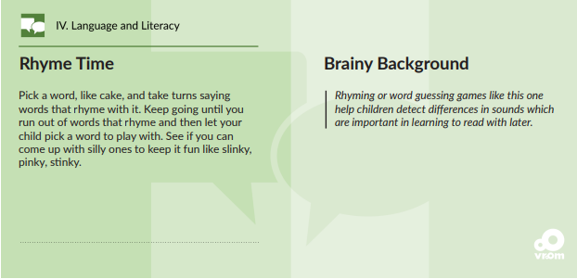

VI. SCIENTIFIC INQUIRY  B. LIFE SCIENCE  1. Demonstrates knowledge related to living things and their environments  VI. B. 1. a. Identifies characteristics of a variety of plants and animals including physical attributes and behaviors | 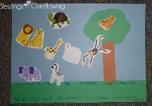  God made the animals.  Genesis 1:27-31  We will learn about animals, and some of the characteristics of animals. We will talk about which animals are wild and which can be pets. | Read, look at pictures, and discuss “Creation” in a children’s picture Bible.  Read books about animal adaptions or animal homes/habitats (e.g., animals living in different places have special features that help them to survive). [From Florida-Office of Early Learning]
III.Social and Emotional Development  D.Sense of identity and belonging 4.Develops sense of self awareness and independence  c. Uses words to demonstrate knowledge of personal information (e.g., hair color, age, gender  or size) | Learn about each other as individuals.  -Who are we?  -What are our likes and dislikes?  -Are you a boy or a girl?  -What color is your hair?  Read We’re different, we’re the same  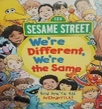 | Have daily conversations with children where children can share personal experiences (e.g., “What was your favorite thing we did today?”).  Sing songs and play games that help children recognize their own unique characteristics (e.g., riddles…”Who has brown hair in our family? Who has green eyes and likes pizza?”).

