Peek at Our Week
Standard |  | Activity |  | Home Extension
III. SOCIAL AND  EMOTIONAL DEVELOPMENT  D. SENSE OF IDENTITY AND BELONGING  1. Develops sense of identity and belonging through play  III. D. 1. a. Engages in associative play and begins to play cooperatively with friends |  | Learning the names of others in class.  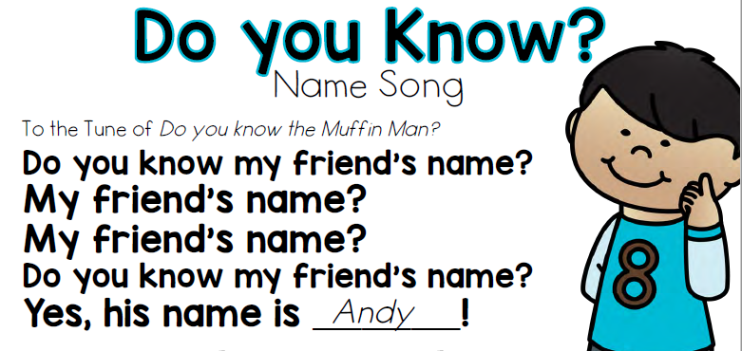 |  | Ask your child about the friends they have met at school.  “What are their names?”  “What do you like to play together?”
V. MATHEMATICAL THINKING  A. Number sense  2. Counts and identifies the number sequence “1 to 10.” |  | Each Day we will be counting verbally in the classroom. We will start with 0-10 and by the end of the year we will be counting to at least 30.  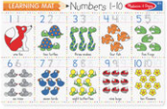 |  | 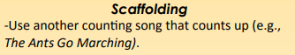  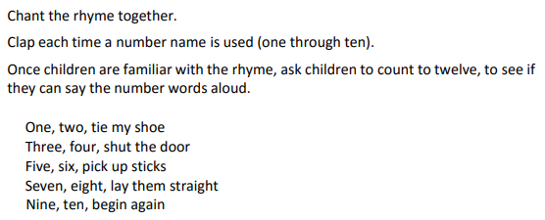
III.Social and Emotional Development  D.Sense of identity and belonging 4.Develops sense of self awareness and independence  c. Uses words to demonstrate knowledge of personal information (e.g., hair color, age, gender  or size) | Learn about each other as individuals.  -Who are we?  -What are our likes and dislikes?  -Are you a boy or a girl?  -What color is your hair?  Read We’re different, we’re the same  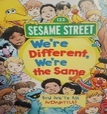 |  | Have daily conversations with children where children can share personal experiences (e.g., “What was your favorite thing we did today?”).  Sing songs and play games that help children recognize their own unique characteristics (e.g., riddles…”Who has brown hair in our family? Who has green eyes and likes pizza?”).

Parent Resources:
The Florida VPK Standards that we follow in our class, can be viewed at this website:
http://www.floel.org/standardsresource/standards.html#d=I,II,III,IV,V,VI,VII,VIII&a=four_year_olds

