Peek at Our Week
Standard | Activity |  |  | Home Extension
IV. Language and Literacy  F. Emergent Reading  3. Shows alphabetic and print knowledge  Benchmark a. Recognizes that print conveys meaning  IV. Language and Literacy  A. Listening and understanding  1. Demonstrates understanding when listening  Benchmark a. Engages in multiple back-and-forth communicative interactions with adults | 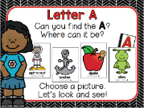  This week we will start with “Our Letter of the Week.” Our letter this week is “Aa.” |  |  | Singing the ABCs is always a good practice at this age. Slowing down when you get to the letters  “L, M, N, O, P” helps children hear each letter separately. Also, pointing to the letters as you sing is helpful. Does your child have a letter “Aa” in her or his name? If so, you may point out the letter and make a connection to the ABC song.
V. MATHEMATICAL THINKING  C. Patterns  1. Identifies and extends a simple AB repeating pattern | ABAB Pattern Practice |  |  | 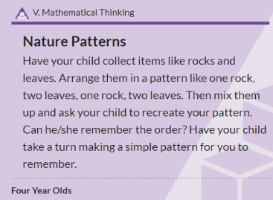
FAITH FORMATION  Plays, works and prays happily with others.  Develops a sense of awe and wonder, respect, gratitude and stewardship for God’s creation. |  | CREATION-In the Beginning there was Nothing but God. Day 1-God said, “Let there be Light.” Genesis 1:3  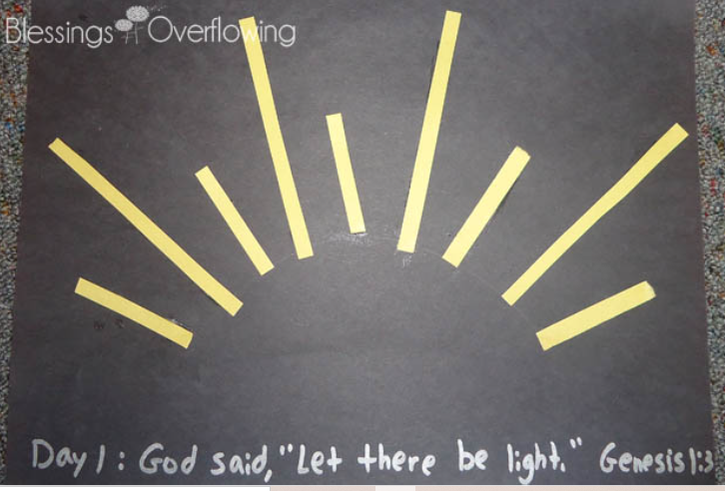  We begin our book about God’s Creation. | Caring for God's Creation  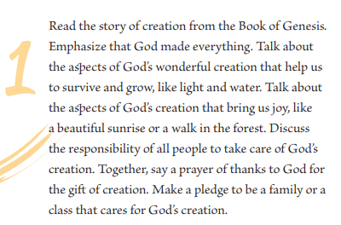  https://go.sadlier.com/religion/caring-for-gods-creation-ebook

