Peek at Our Week
Standard | Activity | Home Extension
SAFE ENVIRONMENT STANDARDS  Standard 3- Behavioral Development  SEBD: 3b Understanding that feelings can be managed.  SEBD: 3c How friends treat each other with respect. (Treating friends with respect builds character. The Character Kids.) | 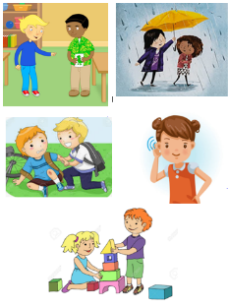  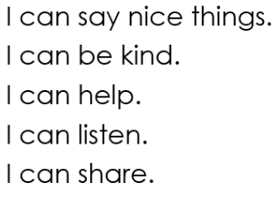 | Scholastic  13 Ways to Raise a Caring and Compassionate Child  https://www.scholastic.com/parents/family-life/social-emotional-learning/social-skills-for-kids/13-ways-to-raise-caring-and-compassionate-child.html
V. MATHEMATICAL THINKING  D. GEOMETRY  V. D. 2. Describes, sorts and classifies two- and three-dimensional shapes using some attributes such as size, sides and other properties | Sorting objects into groups in two different ways (size and color):  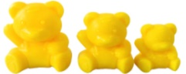  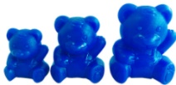 | Sort toys or other objects at home by an attribute such as size, color, type of toy, matching socks, dad’s clothes vs. child’s clothes, etc.
FAITH FORMATION  Plays, works and prays happily with others.  Develops a sense of awe and wonder, respect, gratitude and stewardship for God’s creation. | CREATION- On the second day God separated the water from the sky (Genesis 1:6-8).  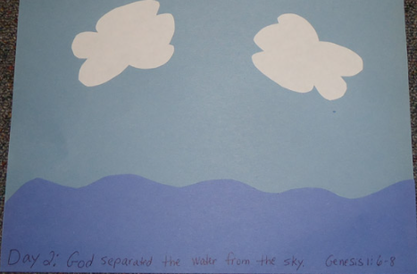 | Here is a Creation Song you may sing at home.  (Sung to the tune of Frere Jacques)  God created! God created!  Night and day, night and day.  That was on the first day.  That was on the first day.  And it was good! It was good!  God created! God created!  Sky and clouds, sky and clouds.  That was on the second day.  That was on the second day.  And it was good! It was good.

