Peek at Our Week
Standard | Activity | Home Extension
VII. SOCIAL STUDIES  B. INDIVIDUAL DEVELOPMENT AND IDENTITY  VII. B. 1. Identifies characteristics of self as an individual  VII. B. 2. Identifies the ways self is similar to and different from peers and others  D. SENSE OF IDENTITY AND BELONGING  4. Develops sense of self-awareness and independence  Benchmark c.  Uses words to demonstrate knowledge of personal information (e.g., hair color, age, gender or size) | 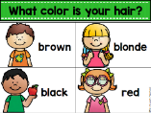  All About Me  Charting our hair colors Learning about the parts of the body  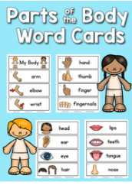  Rhyming with body part words  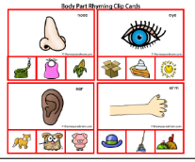 | Have your child discuss different attributes (such as eye color, hair color, what they are good at) that make them an individual. You can help your child compare the attributes with other family members.  - Sing songs and play games that help children recognize their own unique characteristics (e.g., riddles…”Who has brown hair in our family? Who has green eyes and likes pizza?”).
I. PHYSICAL DEVELOPMENT  A. HEALTH AND WELLBEING  d. Feeding and Nutrition  I. A. d.1. b. Recognizes nutritious food choices and healthy eating habits | 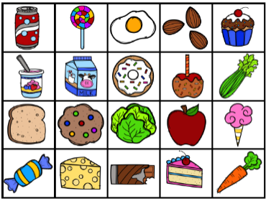  We will be sorting pretend food into categories of “Healthy/Growing Food” vs “Food that we eat for Treats Sometimes.” | Discuss which foods you eat throughout the week that are healthy “growing” foods, that are important to eat each day.

