Peek at Our Week
Standard | Activity | Home Extension
IV. LANGUAGE AND LITERACY  F. EMERGENT READING  2. Shows age-appropriate phonological awareness-Listens and matches rhythm, volume and pitch of rhymes, songs and chants  3. Shows alphabetic and print knowledge  IV. F. 3. a. Recognizes that print conveys meaning | 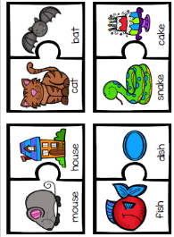  Rhyming Words | 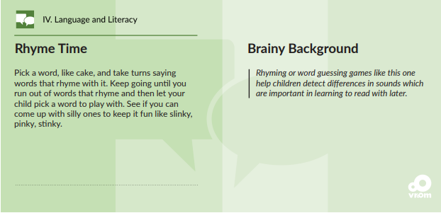
IV. LANGUAGE AND LITERACY  F. EMERGENT READING  3. Shows alphabetic and print knowledge  IV. F. 3. a. Recognizes that print conveys meaning | 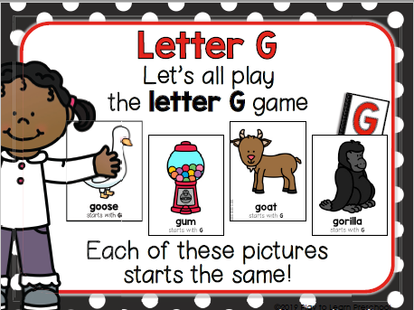  Our letter this week is "Gg" | Florida Office of Early Learning:  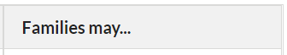  - Sing the alphabet song with children while they are following along looking at the letters.  - Point out words that begin with the same letter as children’s names (e.g., John and jump)
FAITH FORMATION  Faith Development Concepts:  Develops a sense of awe and wonder, respect, gratitude and stewardship for God’s creation.  Ask for and listens to Bible stories. | Creation: REVIEW of Days 1-7  Putting our Creation Pictures together into a book, and making a cover.  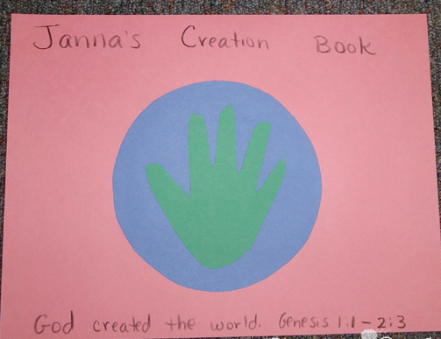 | We will be sending home the Creation Book that your child has made during this unit. You may occational read and look through the pictures he/she made. Perhaps they will want to talk some of the pictures with you.

