Peek at Our Week
Standard | Activity | Home Extension
IV. LANGUAGE AND LITERACY  F. EMERGENT READING  IV. F. 2. b. Combines words to make a compound word (e.g., “foot” + “ball” = “football”)  3. Shows alphabetic and print knowledge  IV. F. 3. a. Recognizes that print conveys meaning | Our letter this week is "Ee"  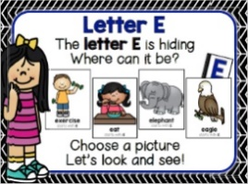  Compound Word Practice  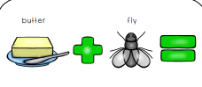  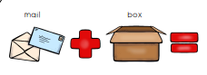 | Families may...  - Play a word game, saying the first part of a compound word and asking children to provide a variety of second words that make real compound words (e.g., say “sun” and encourage responses like “flower,” “shine” and “burn.”).
V. MATHEMATICAL THINKING  F. MEASUREMENT AND DATA  V. F. 3. Seriates (places objects in sequence) up to six objects in order by height or length (e.g., cube towers or unit blocks) | Size sequencing  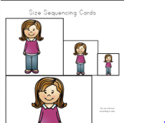Smallest to Largest and Largest to smallest | Families may...  - Provide fun experiences at home by asking children to sequence containers of food, such as cereal boxes or canned goods, found in the kitchen cabinets. Begin with three-four items and increase up to six items as children are able to order the items and describe the arrangements they have made according to size.

FAITH FORMATION  Plays, works and prays happily with others.  Develops a sense of awe and wonder, respect, gratitude and stewardship for God’s creation. | 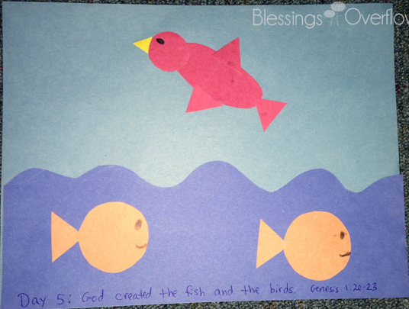  God created the fish and the birds. Genesis 1:20-23 | Read, look at pictures, and discuss “Creation” in a children’s picture Bible.  Read books about plants and animals and their characteristics.

